**SQL**: It’s a basic English-like programming language that’s used to interact with database – SQL is used for managing the relational database

**Relational database**: This is a data storage method that organized info in a series of tables that are connected through data relationships. Data values are stored as few times as possible and tables are linked to one another using keys

**RDBMS**: Oracle, PostgreSQL, MySql, Microsoft Sql server – there are some syntactical differences among differences versions of sequel

The data in database is organized into tables

The visual representation of the way the data is organized and connected in d/b is called ER diagram

**Normalization**: Organizing data in a d/b by establishing relationships b/w tables in order to avoid redundancy and maintain data integrity – process of optimization for data storage

Relational database models use one-to-many, many-to-one, and many-to-many relationships. One-to-one relationships are also possible, but less common.

Primary keys are unique identifiers for every row in a table and can be made up of one or more columns.

If no. of characters will vary from row to row, we use varchar

* We can also use NOT IN as shown in the below screenshot
* We can also use NOT LIKE as shown below
* To select NULL, use IS Null
* Use also IS NOT NULL

+ AND = both conditions must be true in the WHERE clause

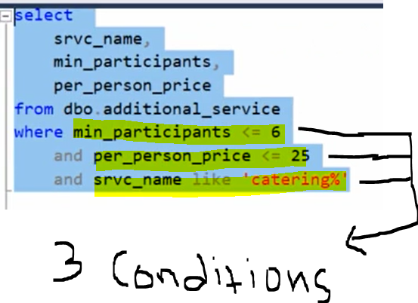

* OR will fetch all as below
* In the below screenshot, we used both AND & OR (the or is mentioned in braces because we need either one of the catering or gift)
* OR will get both the values
* For Count, we can mention * but in sum function, we need to give column name

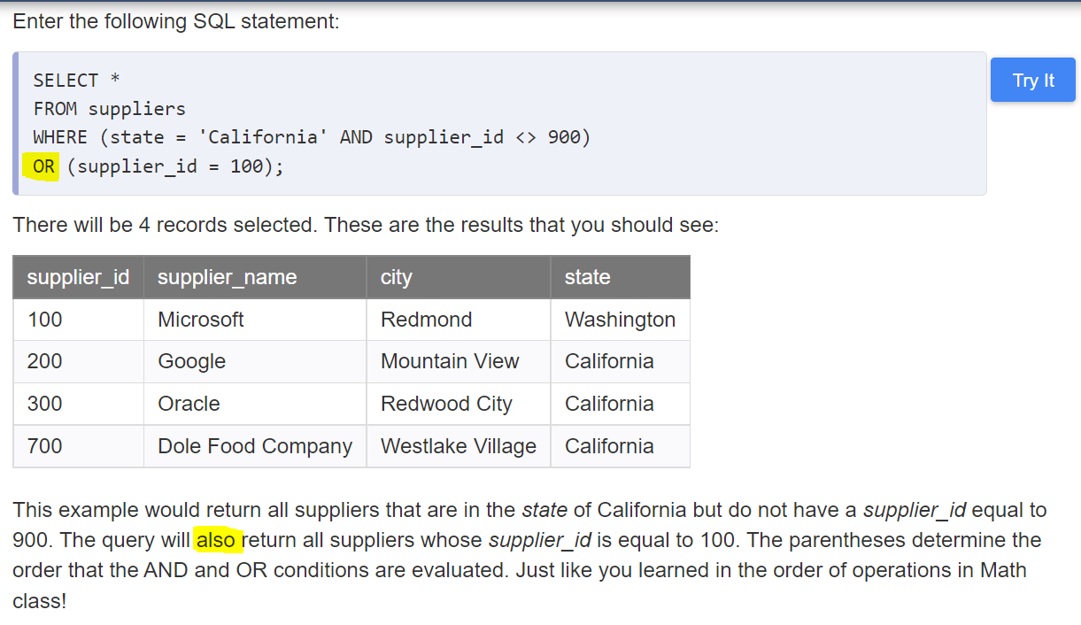

* A bit column can store either a 1, representing true, or a 0, representing false. If a column is declared as NOT NULL, data is required in that column.
* NULL results will not be included when filtering with specific, concrete values. To include NULL results, the user would have to search for rows where number IS NULL.
* Conditions are evaluated in the order that they occur, but conditions in parenthesis are treated as a single unit and are evaluated together.
* The keywords that are already present in the SQL will show in different color, we call these words as reserved words
* In the below screenshot, you will see **ambiguous column name** error, that’s because the column ‘Flavor_id’ is present in both the tables that we are joining. Thus, we need to mention the alias table name before the column names (as in the 2nd screenshot below)

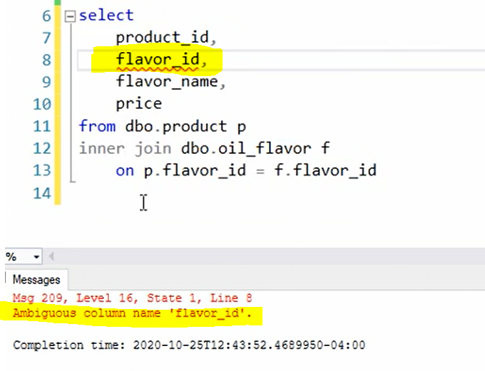

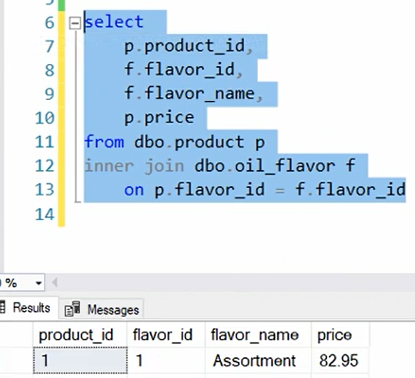

* We can join the 3 tables as shown in the below screenshot

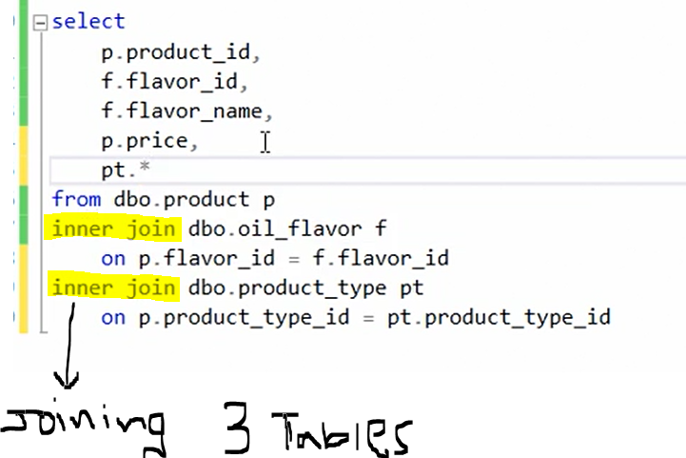

* In the above screenshot, it does not matter the order (P=PT or PT=P) that we mention in ON condition
* In the above screenshot, we can specify table name alias and ‘*’ to get all the columns from PT table

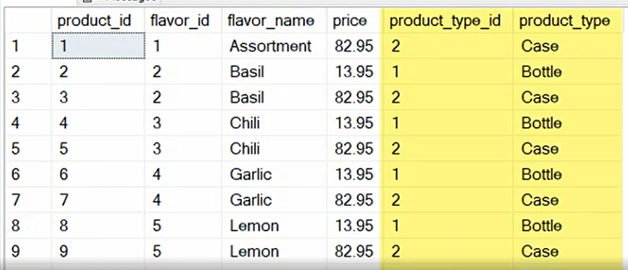

* Left outer join:
* Columns from a subquery/Subselect/nested query/inner query cannot be referenced in the main select list.
* One difference to notice is, Subqueries return either scalar (single) values or a row set; whereas, joins return rows. A Subquery is used to return data that will be used in the main query as a condition to further restrict the data to be retrieved. The subquery can be placed in the following SQL clauses they are WHERE clause, HAVING clause, FROM clause. The good thing in sub-queries is that they are more readable than JOINs: that's why most new SQL people prefer them; it is the easy way; but when it comes to performance, JOINS are better in most cases even though they are not hard to read too.
* We cant reference any columns in sub-query tables in our main select statement, because the select statement will not know anything about the table included in our sub-query and if you want to include the column in the sub-query table, we will have to join – see second bullet under subquery in the below screenshot
* Sub-queries is used to filtering

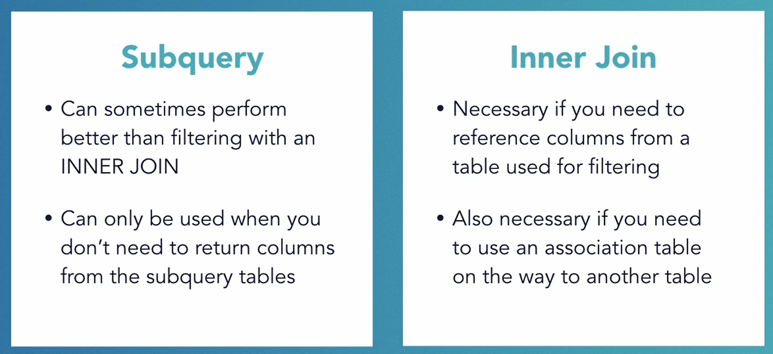

* A total of 64 joins, both inner and outer, are allowed in a single query. The maximum number of joins in a single select statement is 64.
* A foreign key relationship is frequently used as a join condition for both inner and outer joins, but is not required for either.
* Inner joins can filter results, while outer joins do not.
* Only one column can be referenced in the select statement of a subquery.
* **Both subqueries and inner joins can be used to filter, but an inner join must be used if columns from both tables need to be returned in the query results.**
* Table aliases are required when referencing a column name that appears in more than one table in your query, but it is best practice to always include column aliases for clarity.
* Inner joins require membership in both tables, while outer joins only require membership in the anchoring table.
* **Join Condition**: A join condition involves columns that relate two tables in some logical way. A join condition may involve more than one column. This is usually the case when a foreign key constraint consists of multiple columns. **The total number of join conditions in a query is always equal to the total number of tables less one.** Usually a join condition is specified on the foreign key columns of one table and the primary key or unique key columns of another table (on FK=PK). Usually, when you write a join query, you specify a condition that conveys a relationship between the tables specified in the FROM clause. This condition is referred to as the join condition. The join condition specifies how the rows from one table will be combined with the rows of another table. This join condition is usually applied to the foreign key columns of one table and the primary or unique key columns of another table

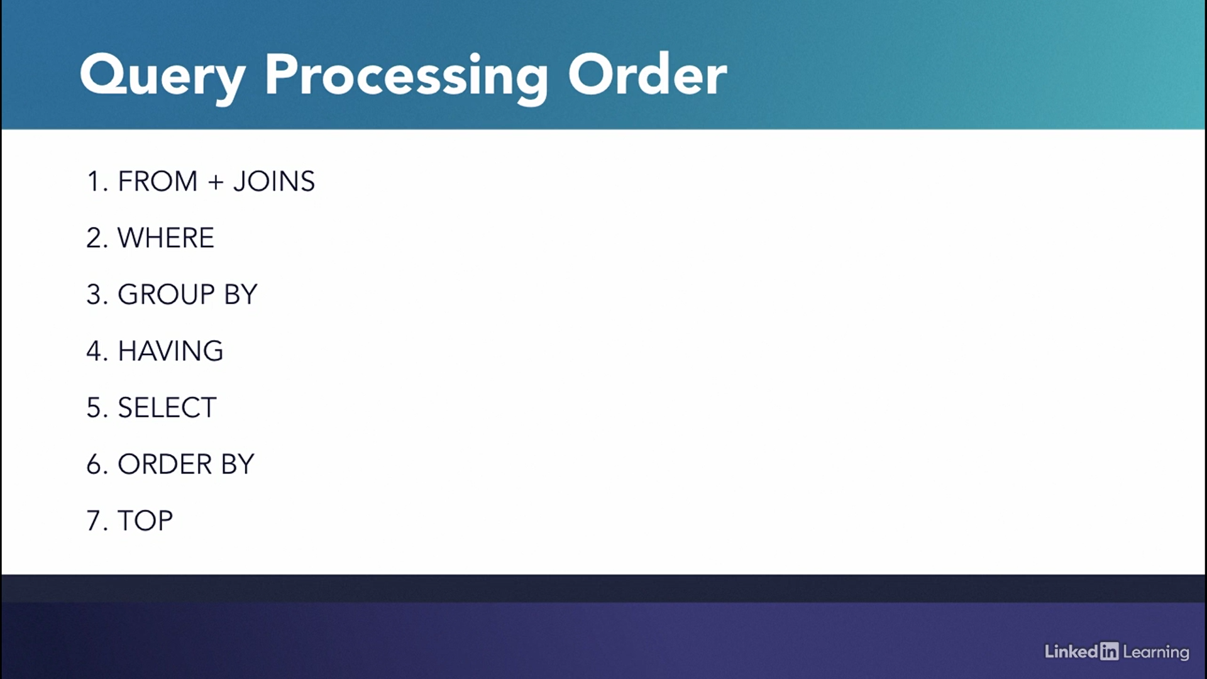

* The SQL SELF JOIN is used to join a table to itself as if the table were two tables; temporarily renaming at least one table in the SQL statement.
* A group by is only required if other columns are included in the select statement; if the aggregate is performed across the entire table, no grouping is required
* Since HAVING is resolved after the GROUP BY clause, it can be used for filtering using the results of an aggregate function.
* SQL Server will throw an error a column is included in the select without being included in the GROUP BY clause when an aggregate function is used
* WHERE is resolved before the GROUP BY clause, so the result of the aggregate function is not available in the WHERE clause.
* WITH is used when adding a query hint (which was not covered in this course).
* WHEN is used in CASE statement syntax.
* A statement is a unit of execution in SQL
* Eg: Select * from Countries Where Continent = ‘Europe’;
* From and Where are Clauses in the above ex. statement
* A Where clause requires an expression that evaluates a value

SELECT FROM WHERE **expression** comparison_operator [ANY| ALL] (subquery)

* SQL is built to operate and manage relational database
* 4 basic functions in sql are CRUD (Create, Read, Update and Delete)
* Relational database is organized into 2-dimentional tables, record/rows and fields/columns
* FK refers to the fields of other table - Foreign keys refer to the primary key in another table to link the two tables together.
* The unpopulated columns in the insert statement are given a null value.
* The asterisk in Count function permits null or empty data, also Strings are acceptable matches for an asterisk.
* If you use UPDATE and SET without a WHERE clause, Without a restriction, the statement applies to the whole table.
* Like CREATE TABLE, DELETE FROM and INSERT INTO are also the statements and ; will end the statement
* We specify the **database schema or column definition or table schema** in the braces in the CREATE TABLE statement
* AS Clause will create an alias identifier
* Offset 5 will fetch the date after 5 rows (6 to 10) and if you give 10, it will get the values from 11th row to 15th row (as we gave limit as 5)
* Order by has to be after Where clause and Limit need to be last
* Count represents the no. of rows in a table
* You can also mention a condition in count – screenshot below
* You can give multiple conditions in the count clause
* When you give column name in the count braces, its going to fetch the count of only where there is data
* You can also specify particular column names and in the values clause, specify only the data for the columns mentioned in the Insert statement

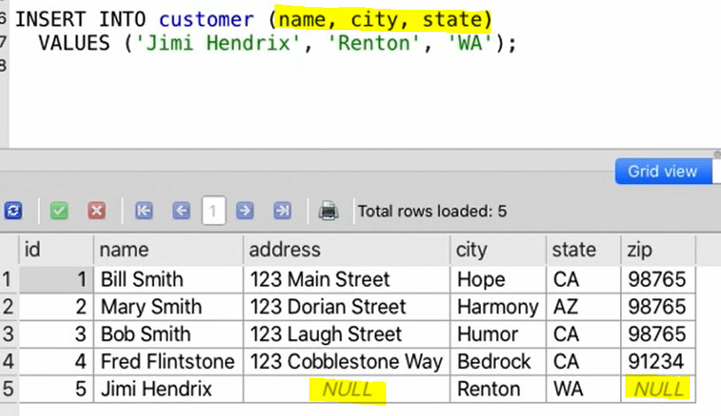

* You can insert values to >1 column as shown in the below screenshot

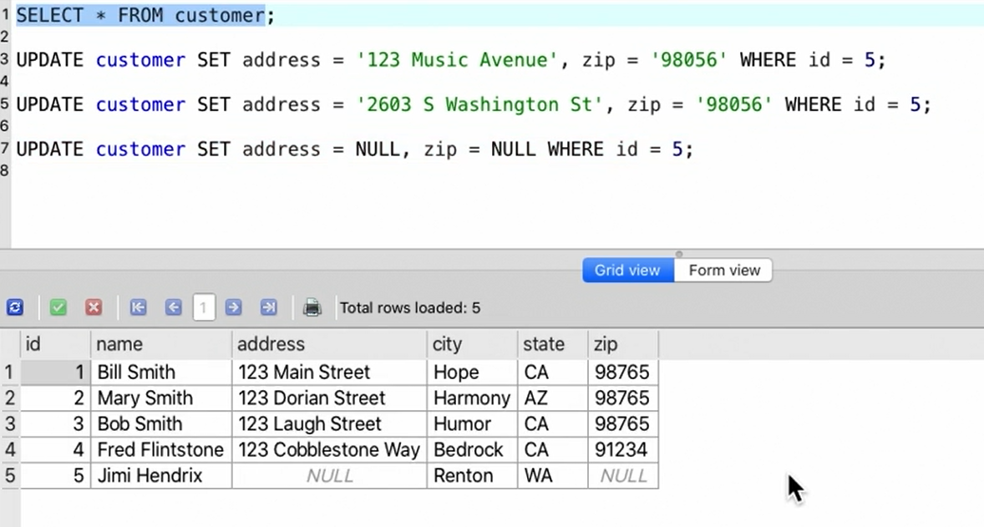

* If you don’t specify the column name in INSERT INTO, the null value will get saved in the database – see below. Also, if you would have defined col A as NOT NULL constraint while creating the table, it will throw an error (as it wont take null)

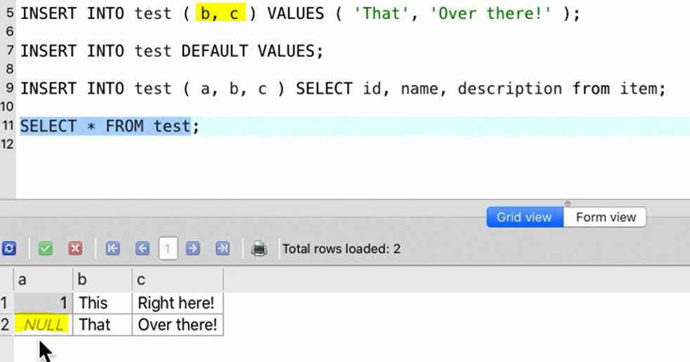

* If you type ‘default values’ in insert statement, the null values will get stored
* We can also insert values from other table as shown below

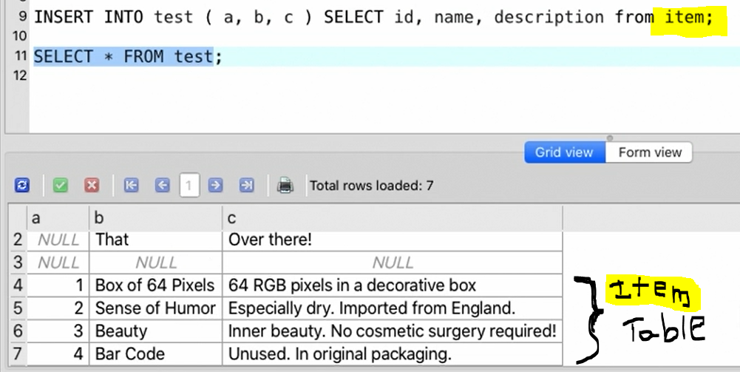

* NULL is not a value, it’s the absence of value, to retrieve the NULL values, we need to use IS NULL

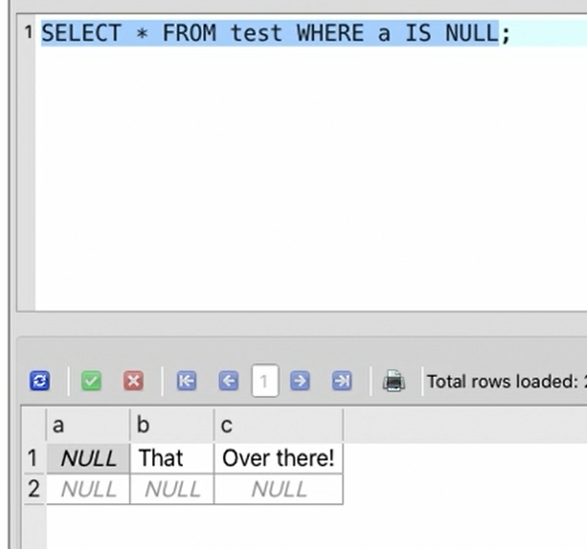

* You can also specify the default value to a particular column while creating the table and if you don’t insert values in this column, then its going to take the default value as shown below

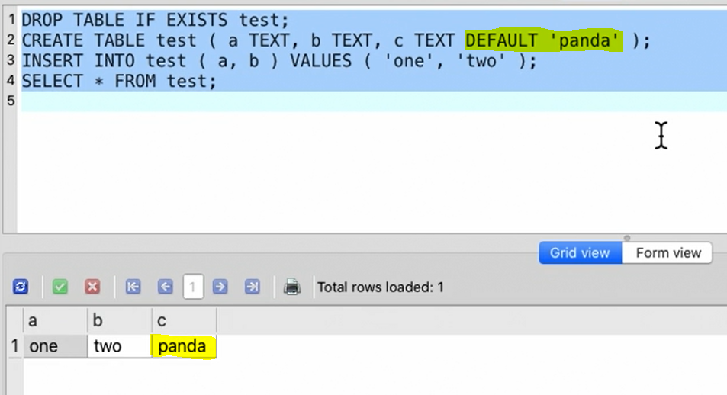

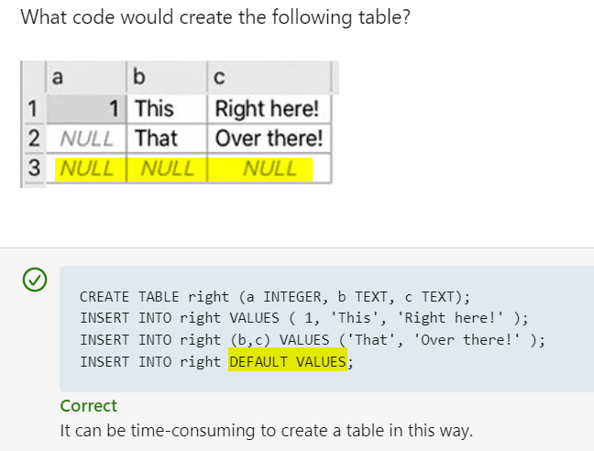

* NULL values is exempt from the UNIQUE constraint. The below is used to place a constraint on a table where a field will contain the value "Mickey" if nothing is provided
* CREATE TABLE People (FirstName TEXT DEFAULT 'Mickey', address TEXT, city TEXT);
* The CREATE TABLE statement is used to create a table with a particular schema.

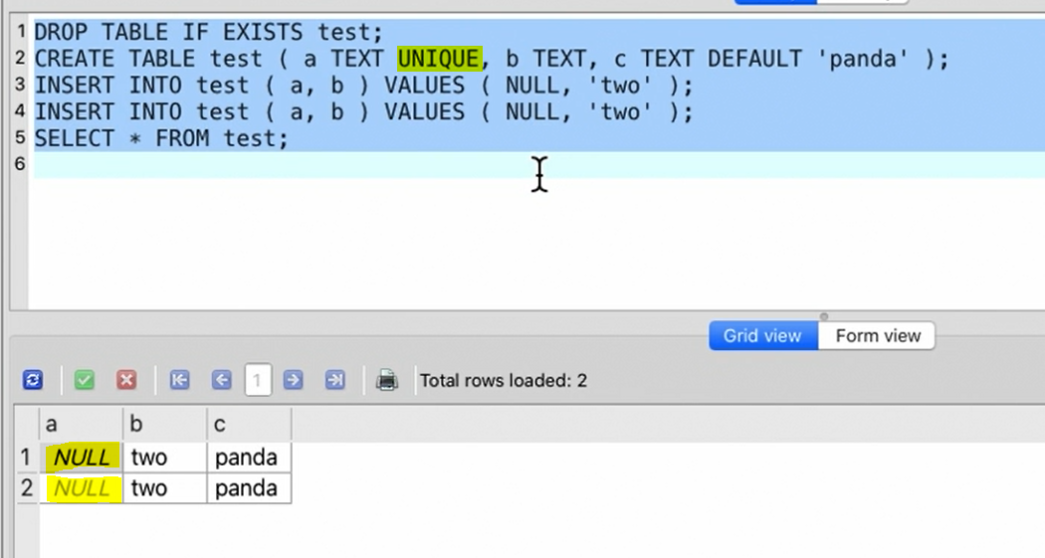

* You can also mention 2 constraints for 1 column – Constraints creates rules that governs the columns while inserting the values

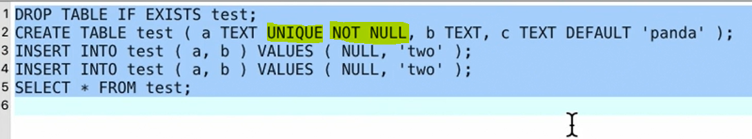

* While defining the table you can also create an id column as below which creates a sequential number for each row. But while inserting the values you need to specify the column names

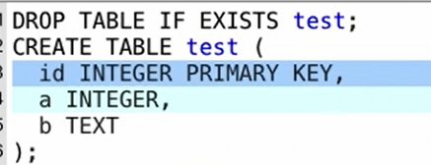

* Every database management system uses its own syntax for ID columns.
* Where Clause will get the rows that we are looking for instead of entire table
* **Difference b/w And and OR operators:** When we use AND to combine two or more than two conditions, records satisfying all the specified conditions will be there in the result. But in case of OR operator, atleast one condition from the conditions specified must be satisfied by any record to be in the resultset. The difference between AND, OR is that AND evaluates both conditions must be true for the overall condition to be true. The OR evaluates one condition must be true for the overall condition to be true.
* **Distinct** is used to get the non-duplicated values - The SELECT Distinct statement removes duplicates from a result set.
* Unique: This ensures that every value in a column is unique with the exception of null values.
* Unique Not Null: This ensures a column will not have any duplicate values including null values.
* In the first CASE clause, we are specifying the column name (a) after the WHEN clause, which means if the value in the column A is 1, then we will get ‘True’ and if the value in the column A is 0, then we will get ‘False’ (A zero is false; anything else is true). Similarly in the second CASE we are specifying A before WHEN clause and giving condition. see screenshot below:

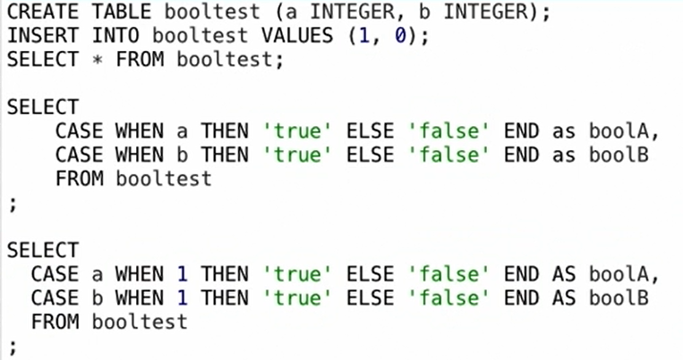

* To insert a blank row use the ‘DEFAULT VALUES’ clause
* The DROP TABLE statement enables you to delete a table from a database and if the table did not exist then attempting to DROP it would cause an error to occur.
* The CASE statement is similar to an IF-THEN-ELSE statement, but it uses WHEN instead of IF.
* The underscore is a single character wildcard, and the percent sign is a wildcard for one or more characters.
* Where clause is used to filter query results by row
* The ORDER BY clause can use multiple columns for ordering criteria.
* This code selects the unique row values from the columns CustomerName and ShopLocation in the eshop table.

**SELECT DISTINCT CustomerName, ShopLocation FROM eshop;**

* **Table Schema**: the number of columns, titles for and data types of columns
* **Inner join**: the result of an inner join will include rows from both tables where the join condition is met
* Similar to table names, we can also create Alias for the columns too – refer below screenshot

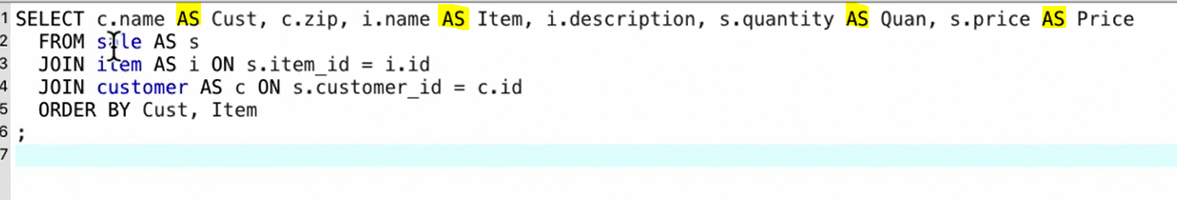

* In the below table, we have joined the 3 tables by giving 2 join conditions (highlighted in yellow)

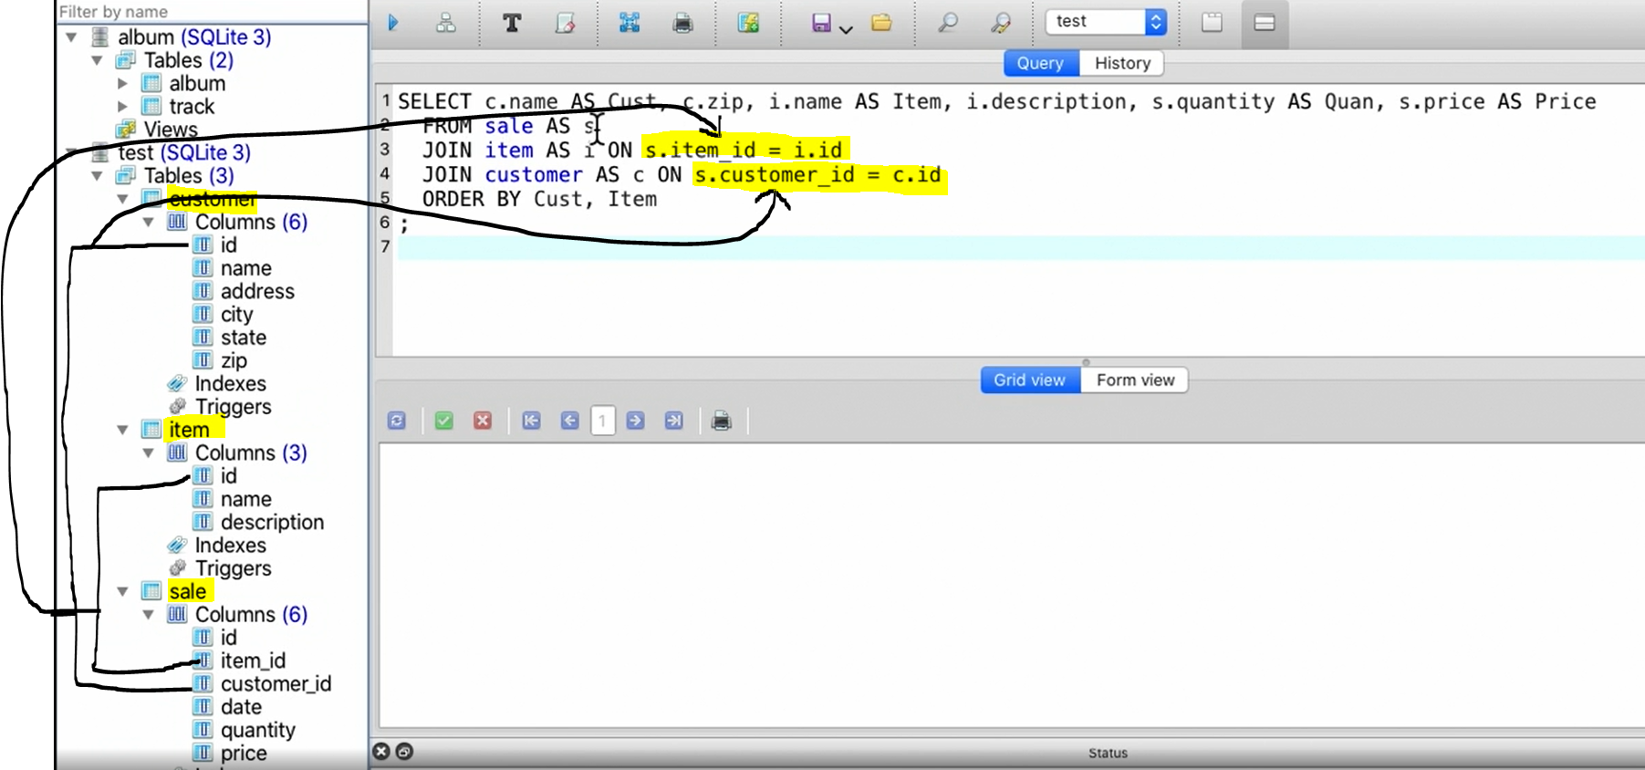

* Junction tables implement the many-to-many relationship of tables.
* The ON clause tells the condition under which the tables will join. But the Join clause is used to combine results from related rows in multiple tables
* The result of an inner join includes the rows from both tables where the join condition is met.
* A joined query can include any no. of tables
* A LEFT JOIN includes rows that match the JOIN criteria as well as non-matching rows from the left table.
* The 6 in the below SUBSTR argument is the starting character from 6TH position till the end. And if you put the 3rd argument, then it will pick up only those characters – see 2nd screenshot from below. The three arguments for the SUBSTR() function in SQLite are ‘string to evaluate, starting position, length of string’. If the length of the substring is not specified in 3rd argument, then the remainder of the string is returned.

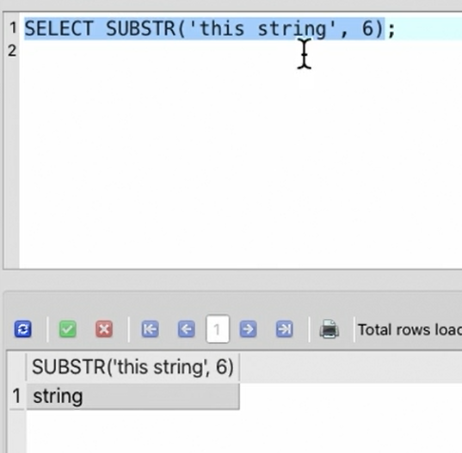

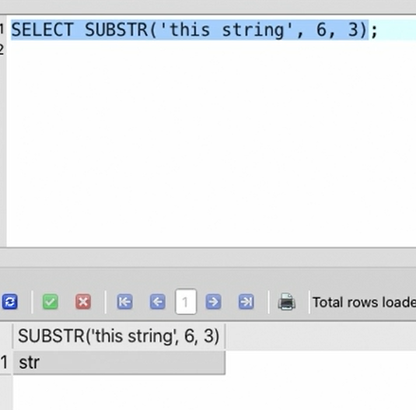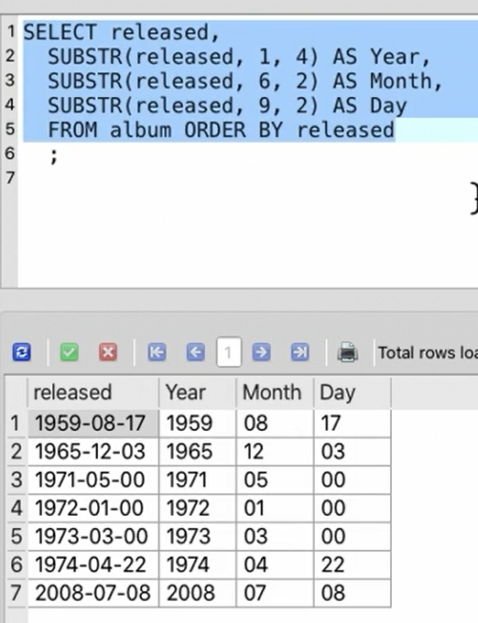

* Trim will remove spaces, LTrim will remove spaces from the left and same with RTrim. If you want to specify the character that you want to remove, give the same in the 2nd argument in TRIM function. Trimming operates from the start and end of the string.
* You can use the TRIM() function to remove Spaces, any character, period from the beginning and end of a string.

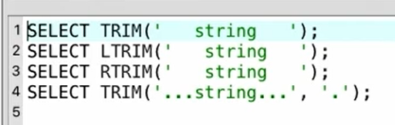

* Give UPPER/LOWER if you want the data to be displayed in upper/lower case as shown in the below screenshot

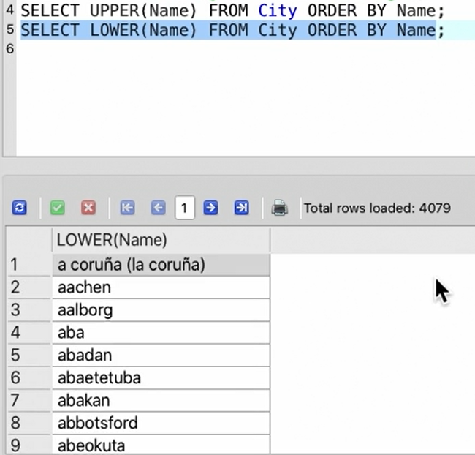

* SQL Data types are totally platform-dependent (datatypes in 1 DBMS is different from other)

**Fundamental Numeric types:**

1. Integer:

* Integer – no fractional part and this is a whole number – Precision is used to specify how many bits are used to represent the integer
* Decimal – this is for fixed precision numbers with a decimal point – these are not real
* Money -

1. Real:

* Real:
* Float

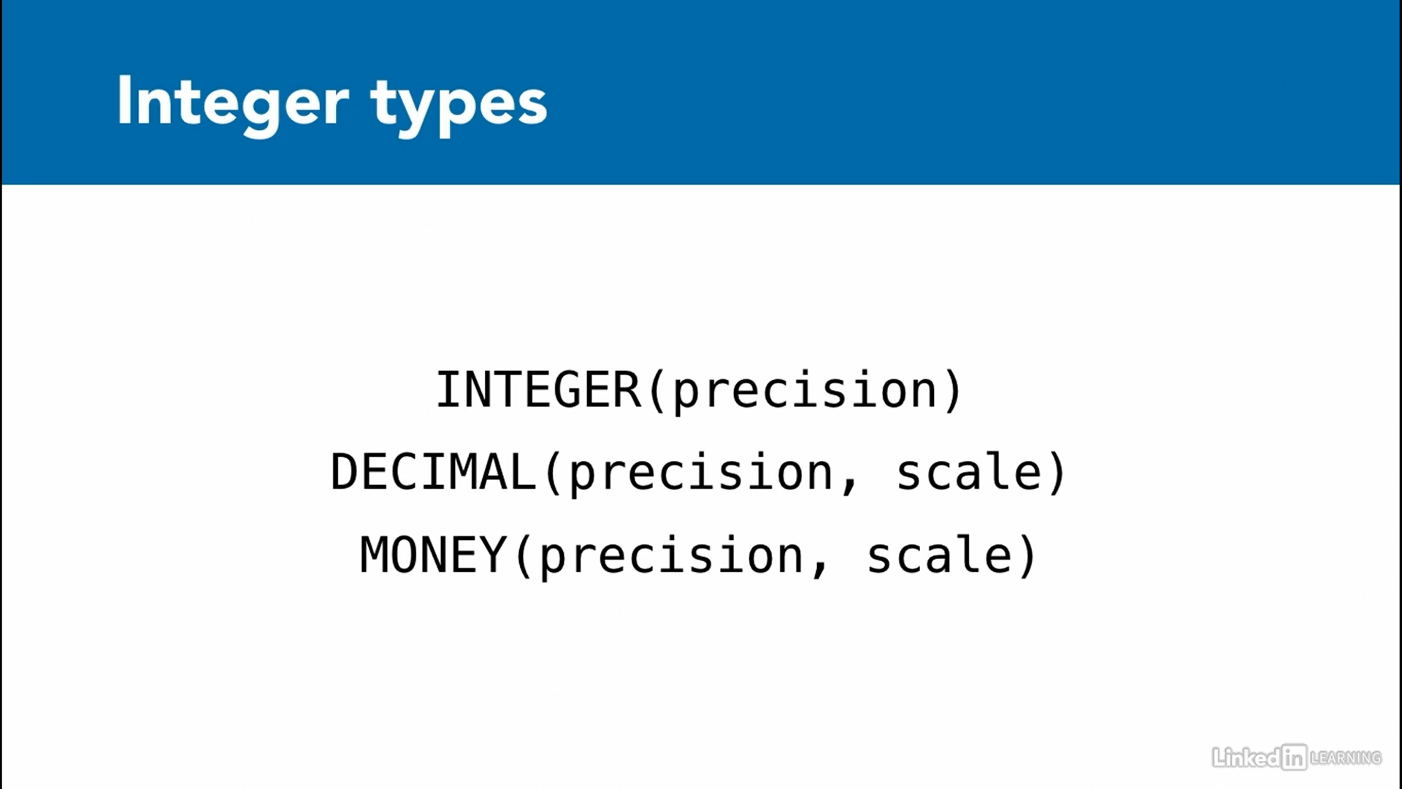

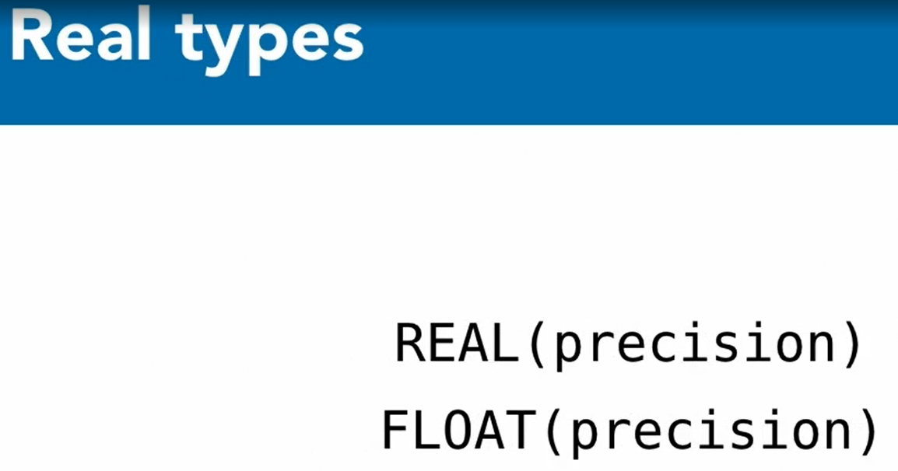

* **TypeOf Function**: This is used to find the type of an expression

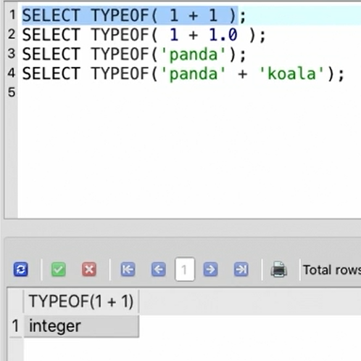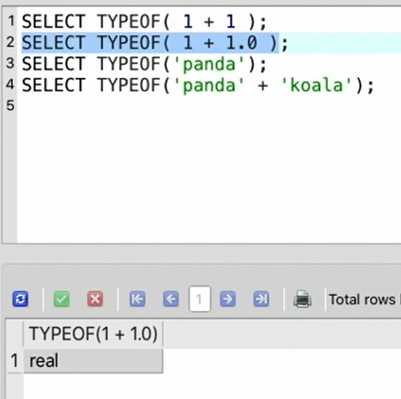

* When you divide the integer, the result will be given in integer only (without decimals) but when you give decimal to one of the operands, then the result will show in decimals (see line2)

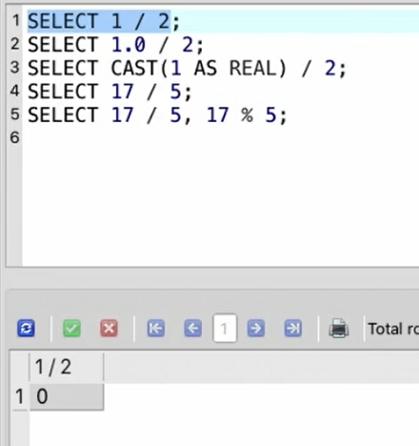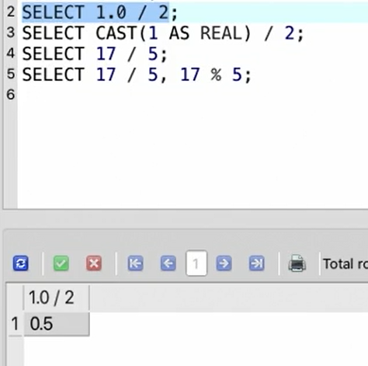

* “Select 9/2.0” will give 4.5 as a result
* When you use CAST function and specify the data type, then the result will give in decimals

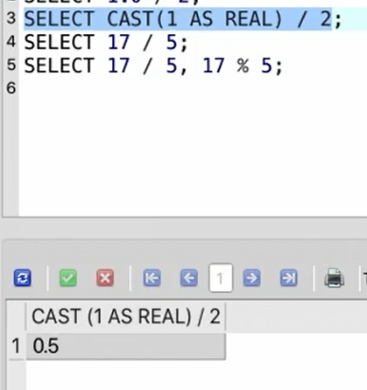

* **Round Function**: Used to round a numeric value to a specific no. of decimal places

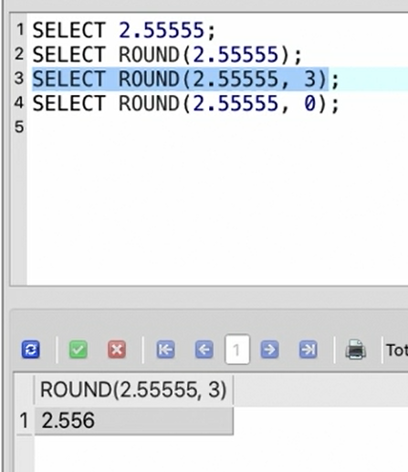

* Use parameter NOW to indicate which time/date
* SQL dates and times are expressed in the UTC time zone.
* The standard format for dates and times in SQL starts with the most significant parts to the left and the least significant to the right.

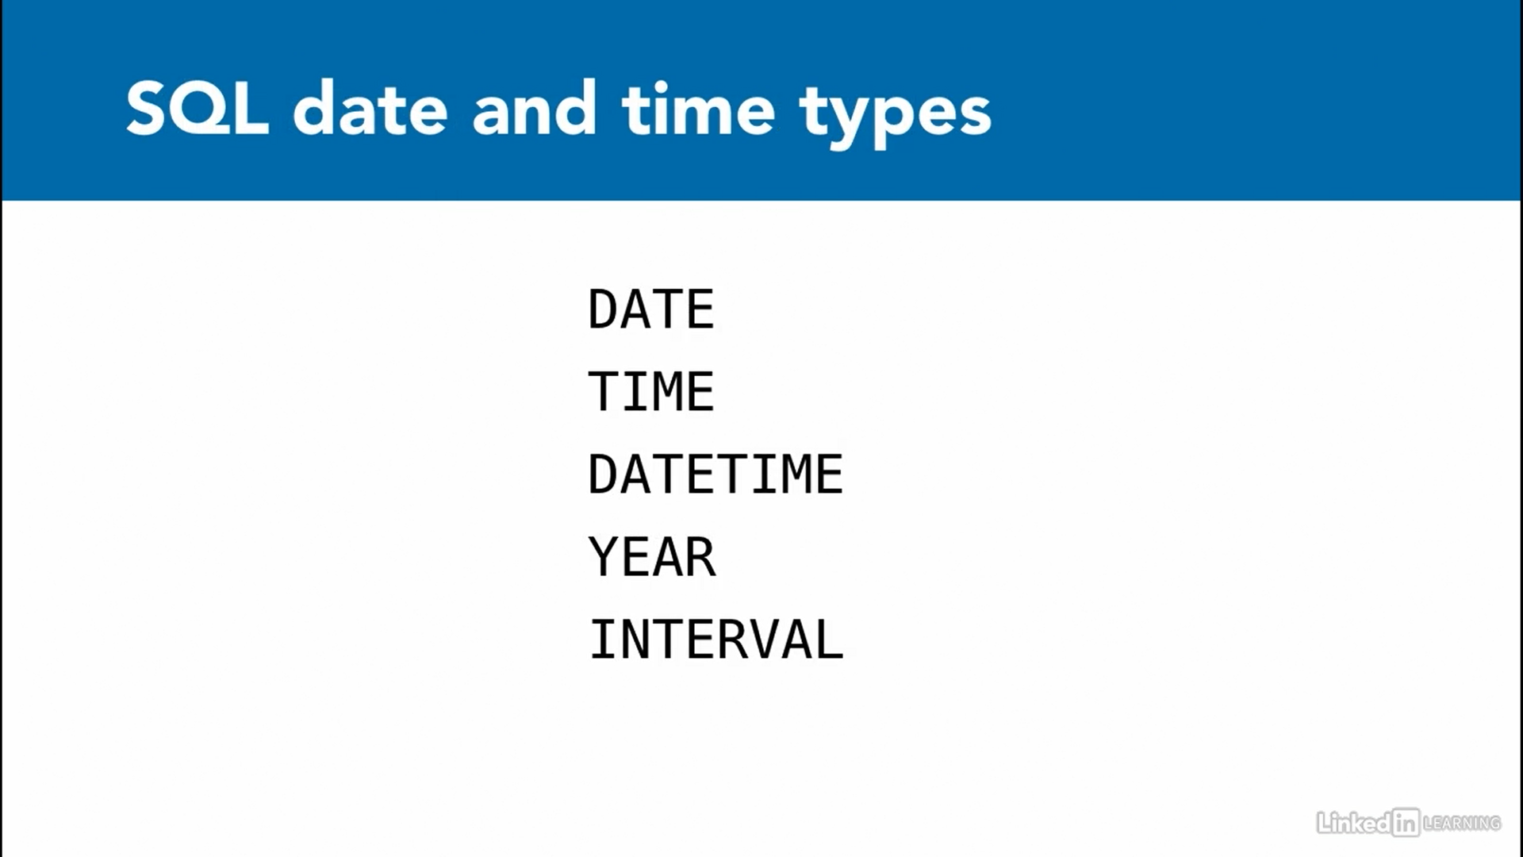

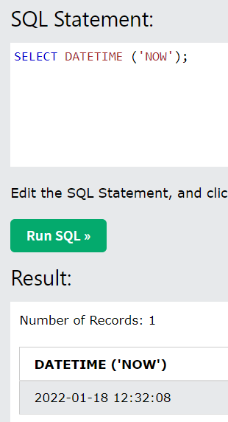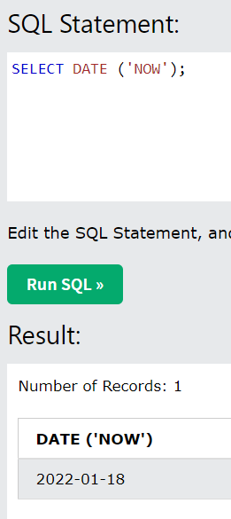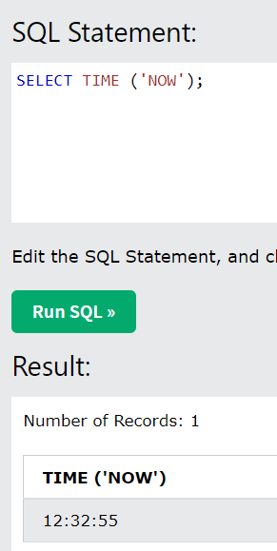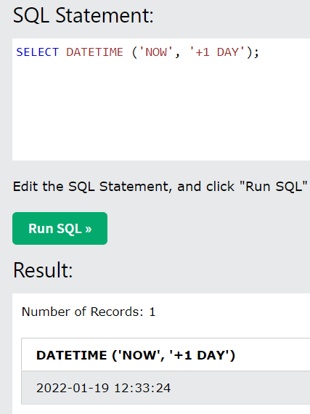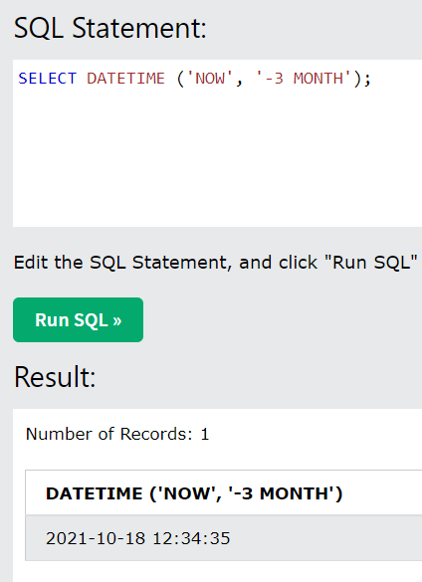

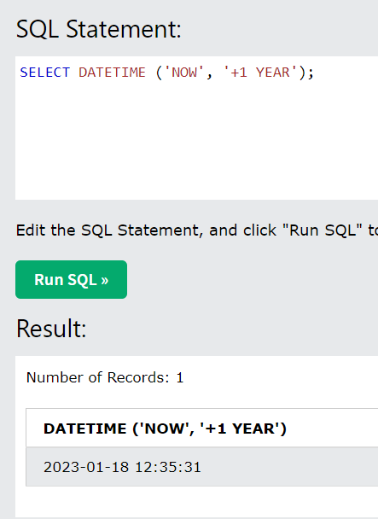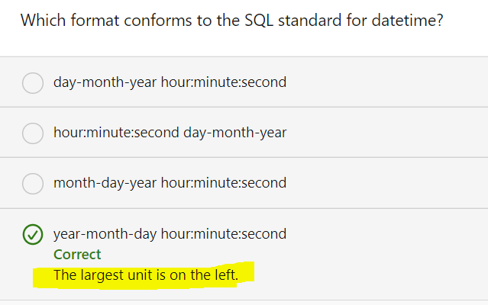

* Aggregate data is info derived from >1 row at a time using aggregate functions
* Select Count (*) from TName = will give you the count of records/rows in that table

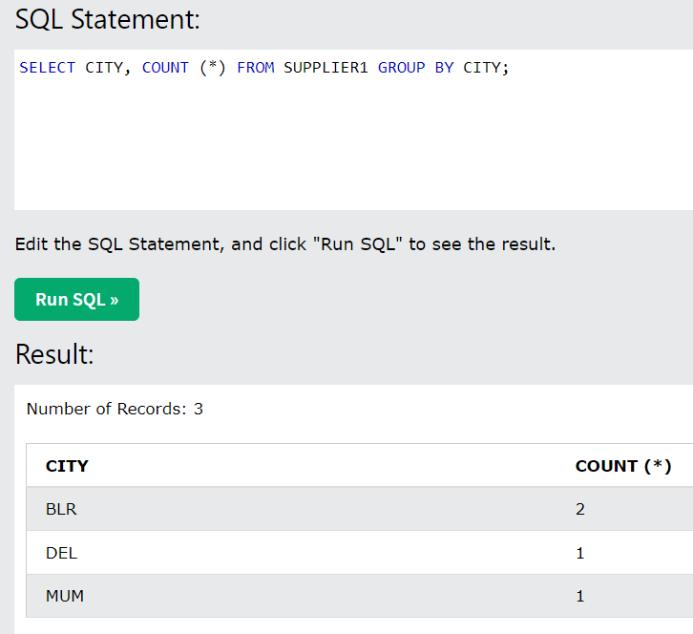

* The Group By Clause groups the results before performing the aggregate functions (like count, sum..)

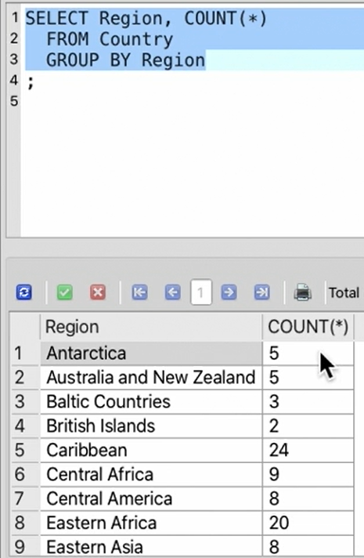

* **Having Clause**: This is like a Where clause but for the aggregated data – its important to have a separate keyword for this as we need to use the Where clause on the non-aggregate parts of same query (to filter the non-aggregated part of the query, we use Where Clause) – Having clause should be after the group by clause because it operates on the aggregated data (Having is used to filter the aggregated queries) - The HAVING clause operates on the data after the aggregation - A HAVING clause generally follows GROUP BY.
* Group By can also be used in the aggregated functions as shown in the below screenshot

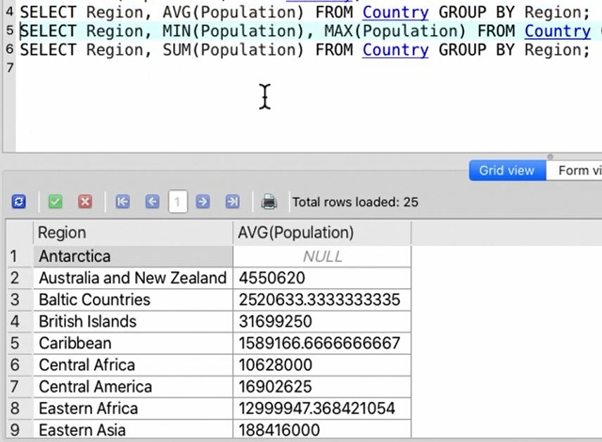

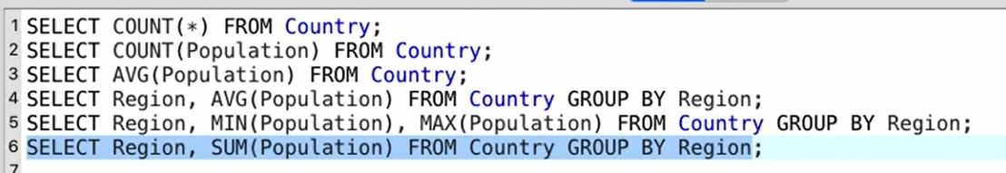

* We cant use any SQL commands/keywords as an alias for any column names or table names

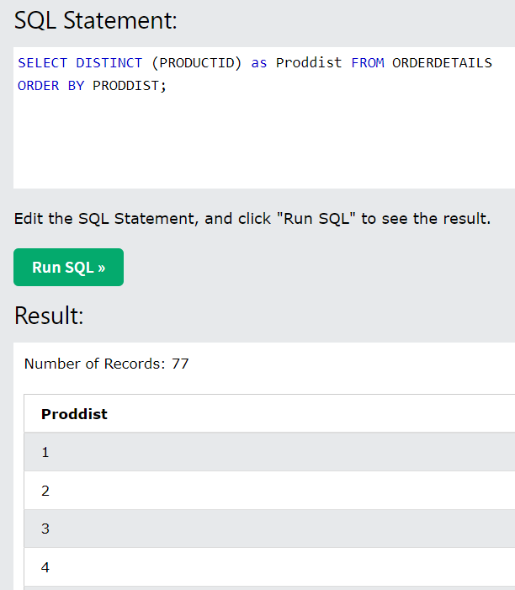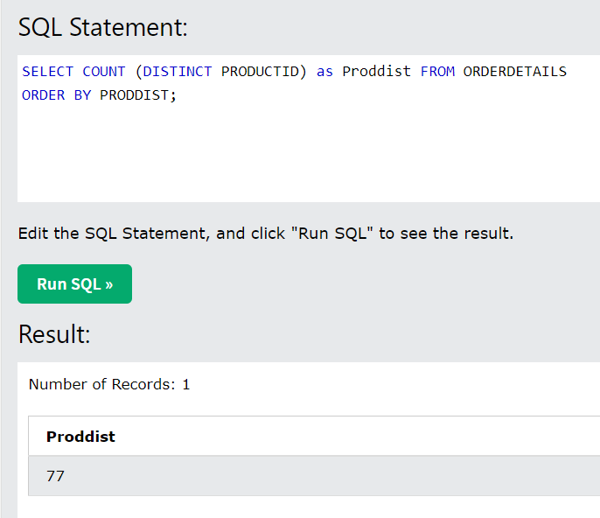

* Distinct can be used with any of the aggregate functions
* All the commands that are present in between the ‘Begin Transaction’ and ‘End Transaction’ will execute as 1 unit. Instead of ‘End Transaction’ few environments will accept COMMIT command - If any of the operations fail, then the entire group of operations fail, and the database is restored to a valid state before the group of operations was started - Transactions allow more efficient processing, and prevent leaving the data in an inconsistent state.
* Transactions ensure that a number of statements are performed as a unit.

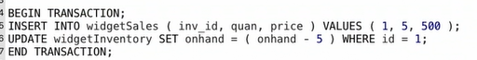

* We can use Rollback command to undo the transaction

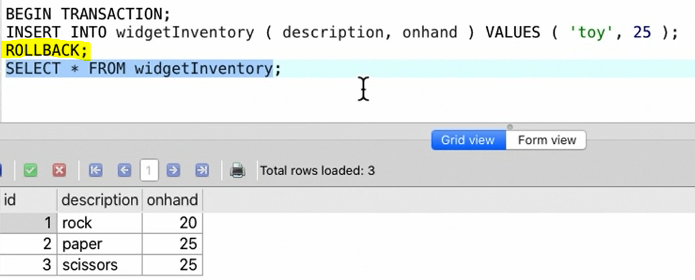

* When you have multiple insertions and if you use these separately between begin and end transaction, it will take comparatively longer time than doing the same job using begin and end transaction commands

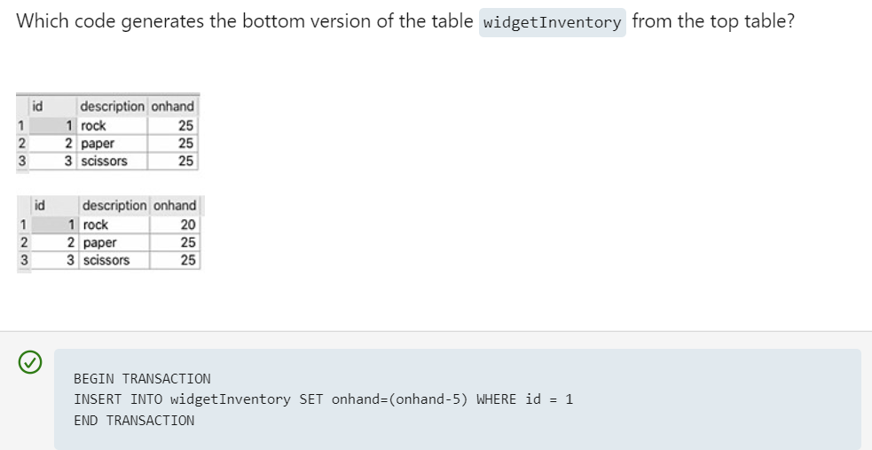

* **Triggers**: These are operations that automatically occurs when specified database event occurs – can also be used to automatically execute a group of statements whenever a specified event occurs - When you drop a table with a trigger, the stored trigger is also deleted from the database.

In the below screenshot, we created a TRIGGER where it executes when any NEW record is updated on WidgetSale table. Here, the NEW in the argument is a keyword

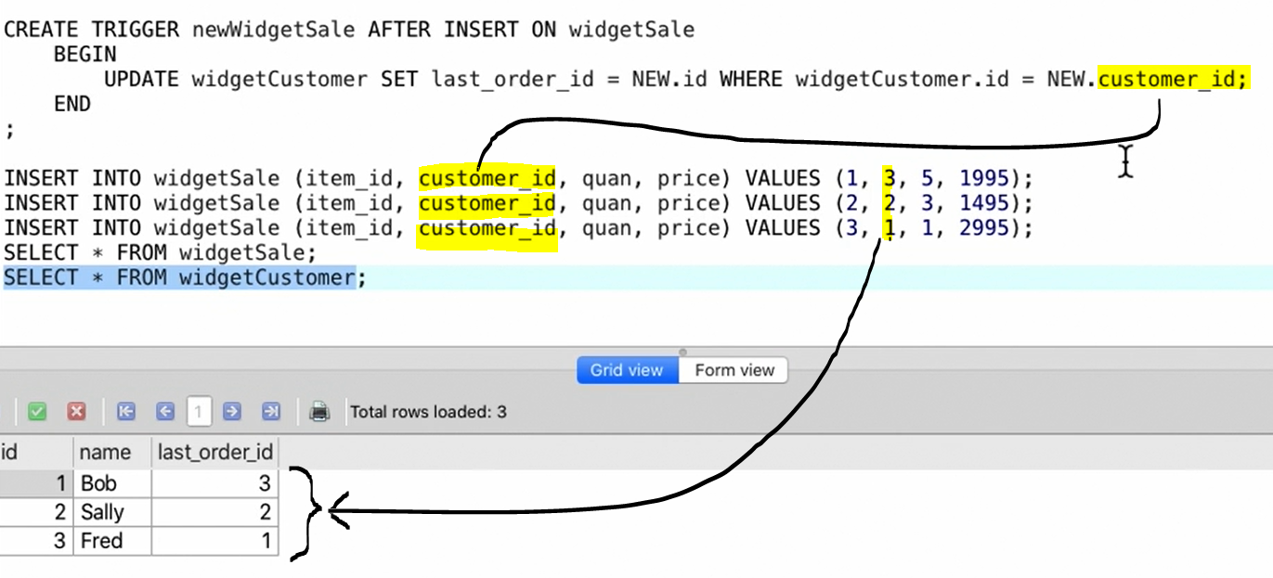

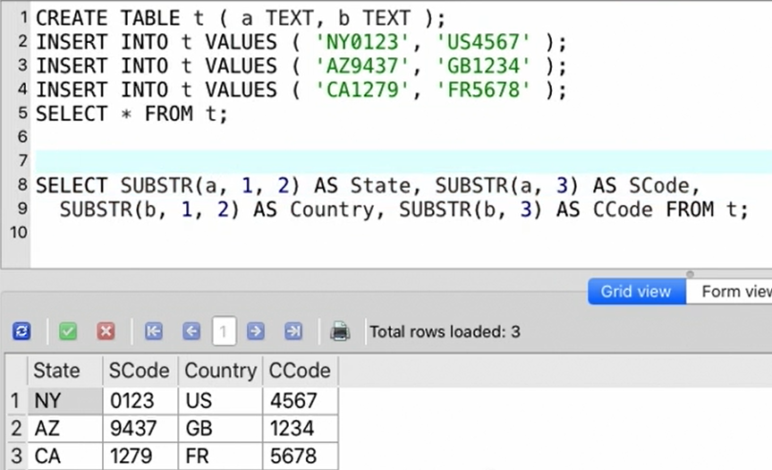

* You can also make the select statement as alias as shown below:

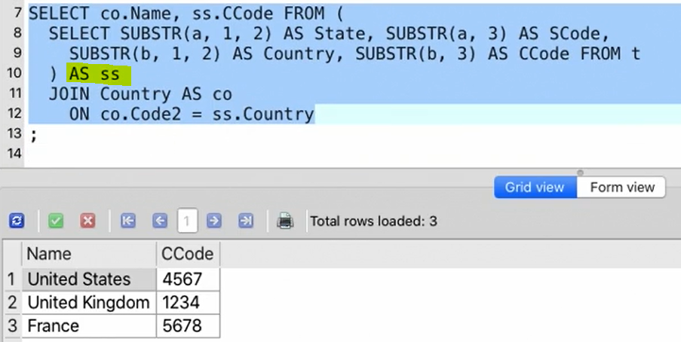

* We can also join the subselect condition with another table (because the result of the select condition is another table itself) – screenshot below

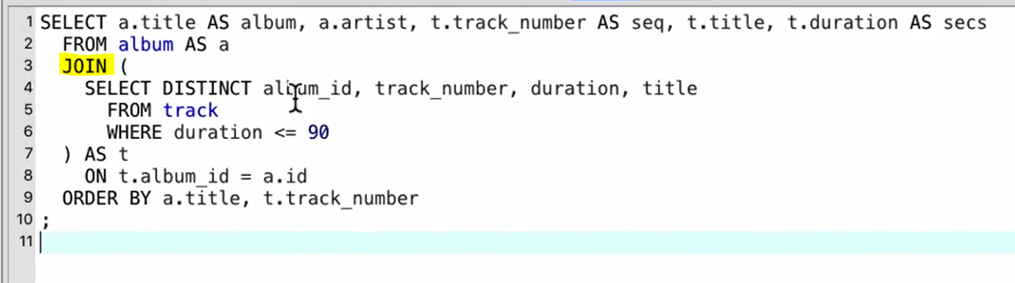

* **Zero Indexing**: The sequential numbering of database line items starts from 0
* **Alternate to Between**: we can also use > AND < to get the range (best to use Between so that we don’t have to repeat column names)

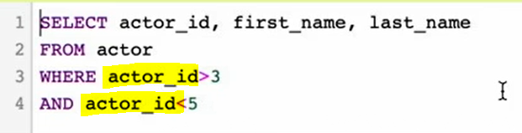

* When we use Between, the numbers specified in this condition are inclusive (this is the difference b/w using <> operators and between operator)

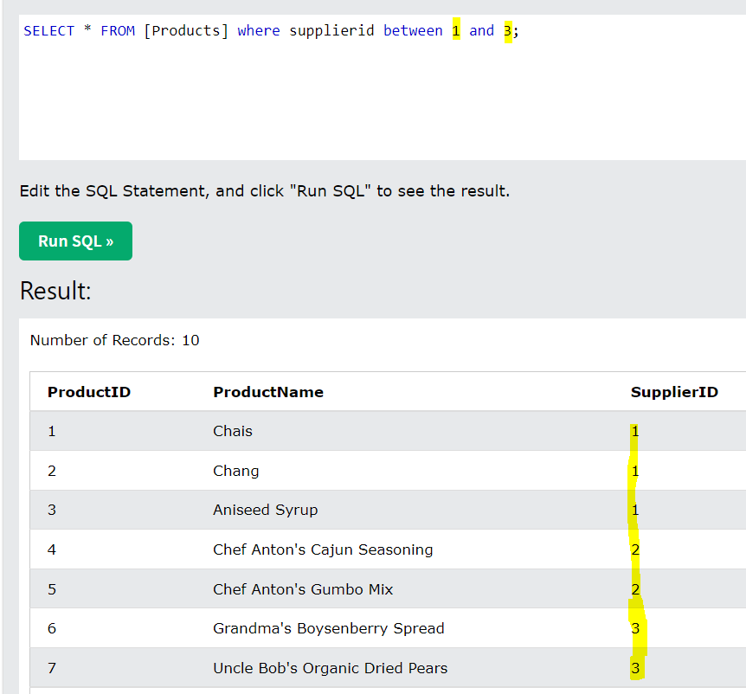

* When you use LIKE wildcards in IN operator, it will throw an error – use % and _ in only LIKE operator

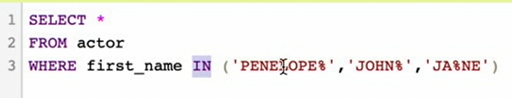

* We can also pull last 4 characters of a name by using ‘-’ operator

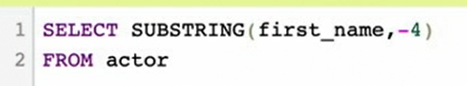

* If you don’t have INITCAP, then we need to use the below substring functions

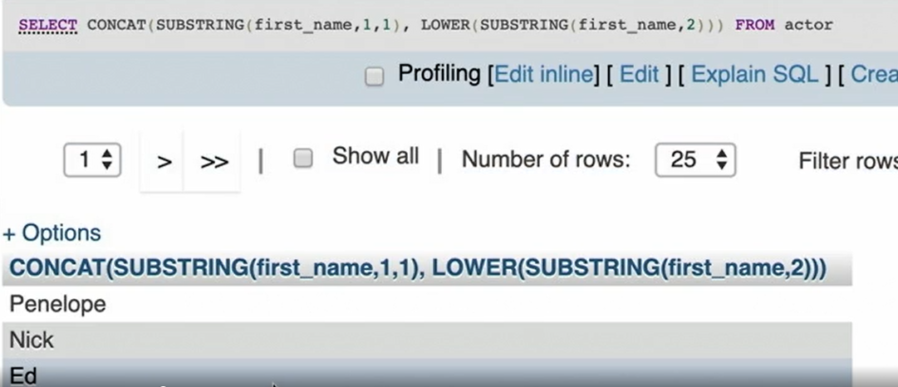

* Spaces before the word is called leading spaces and at the end is called trailing spaces
* When we give just date and query database column that has date and time, you will not get any results (as the SQL considers it as a mid-night time) and if you give > operator, you will see results

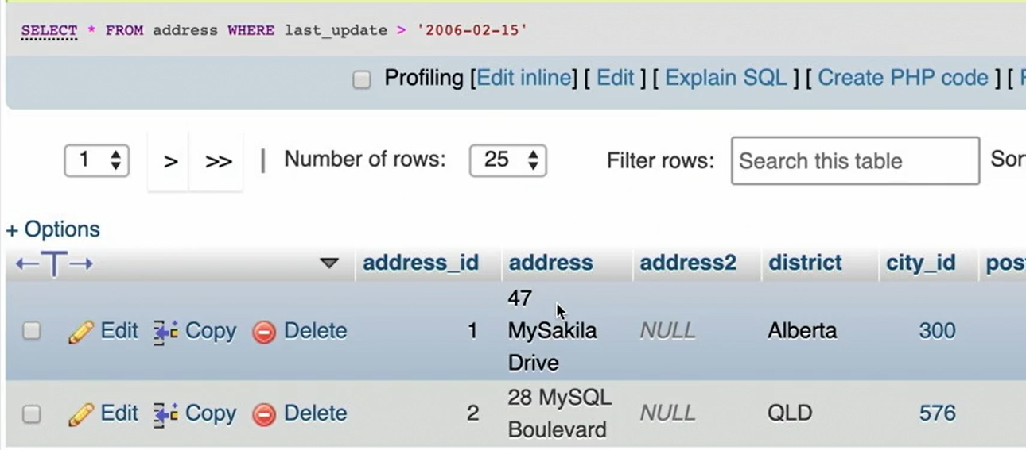

* Parts of date is separated by hyphen symbols and the parts of time is separated in colon symbols
* Count function does not consider null values
* We cant use aggregated column in the Where condition – it will throw an error – use Where only on the columns. It doesn’t mean that we cant use the aggregated column in Where, we can still use by using HAVING function (it’s a keyword used to filter on an aggregated column)

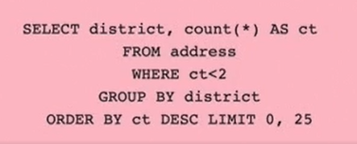

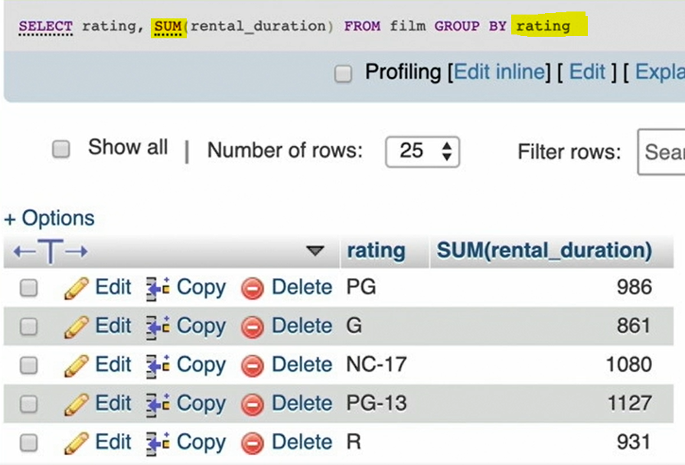

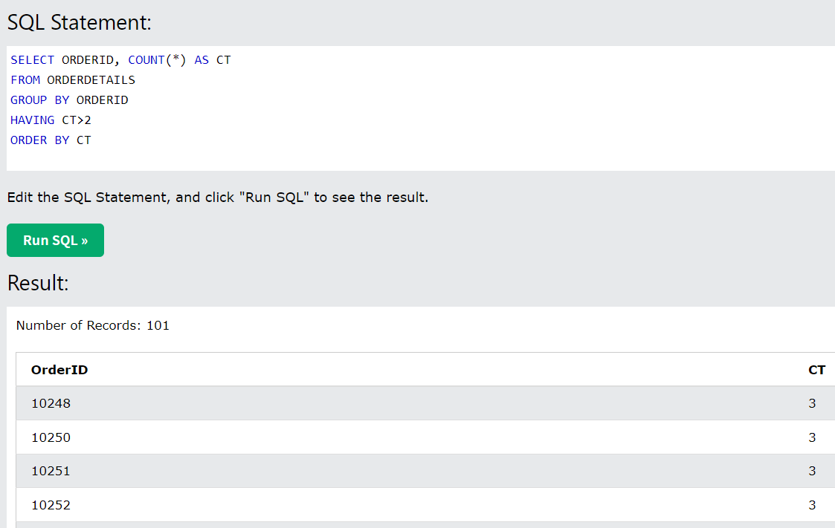

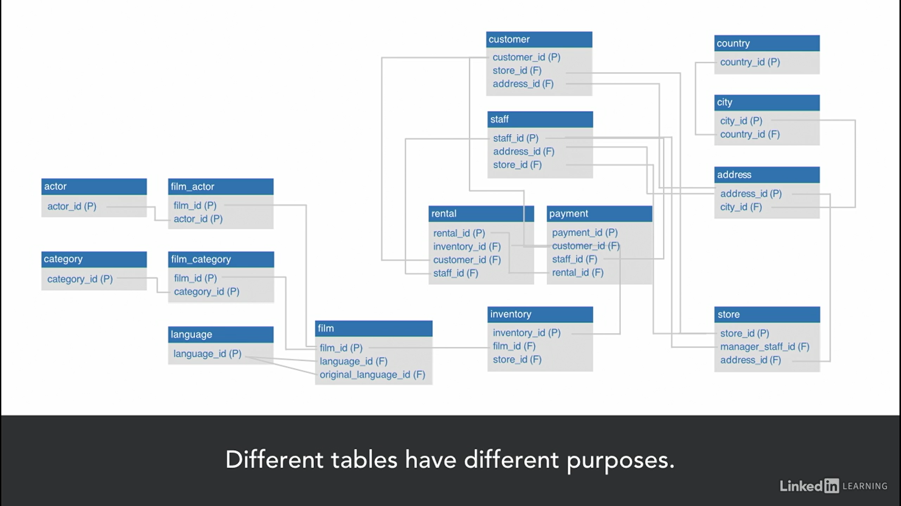

* An outer join will return all rows from Table A and Table B

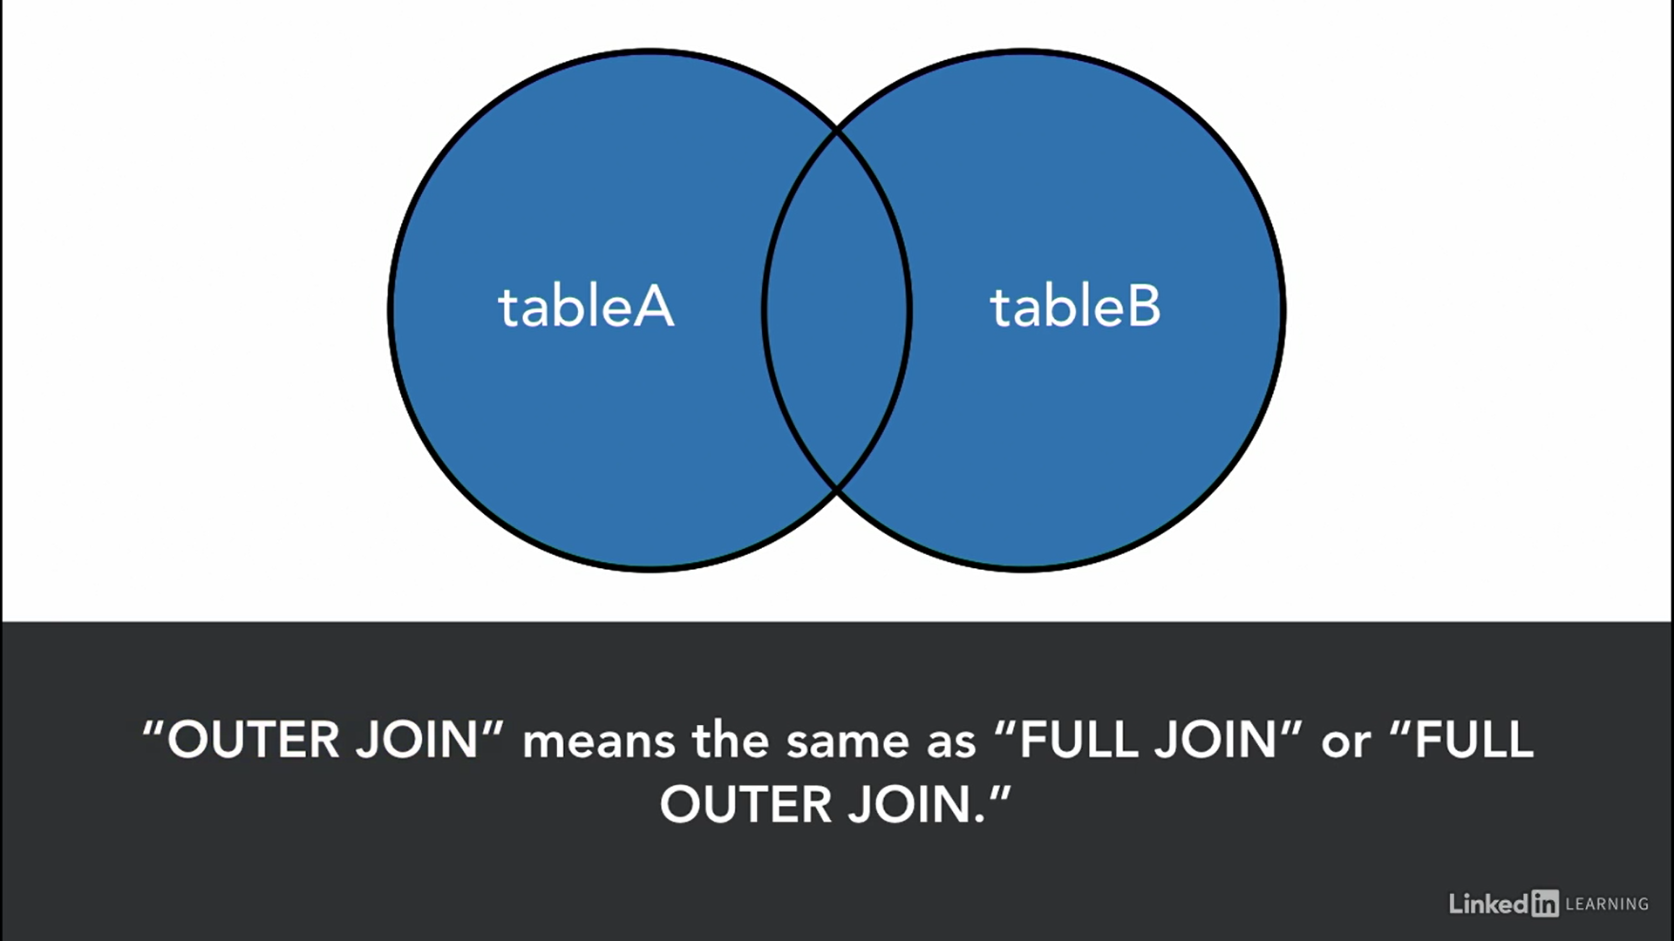

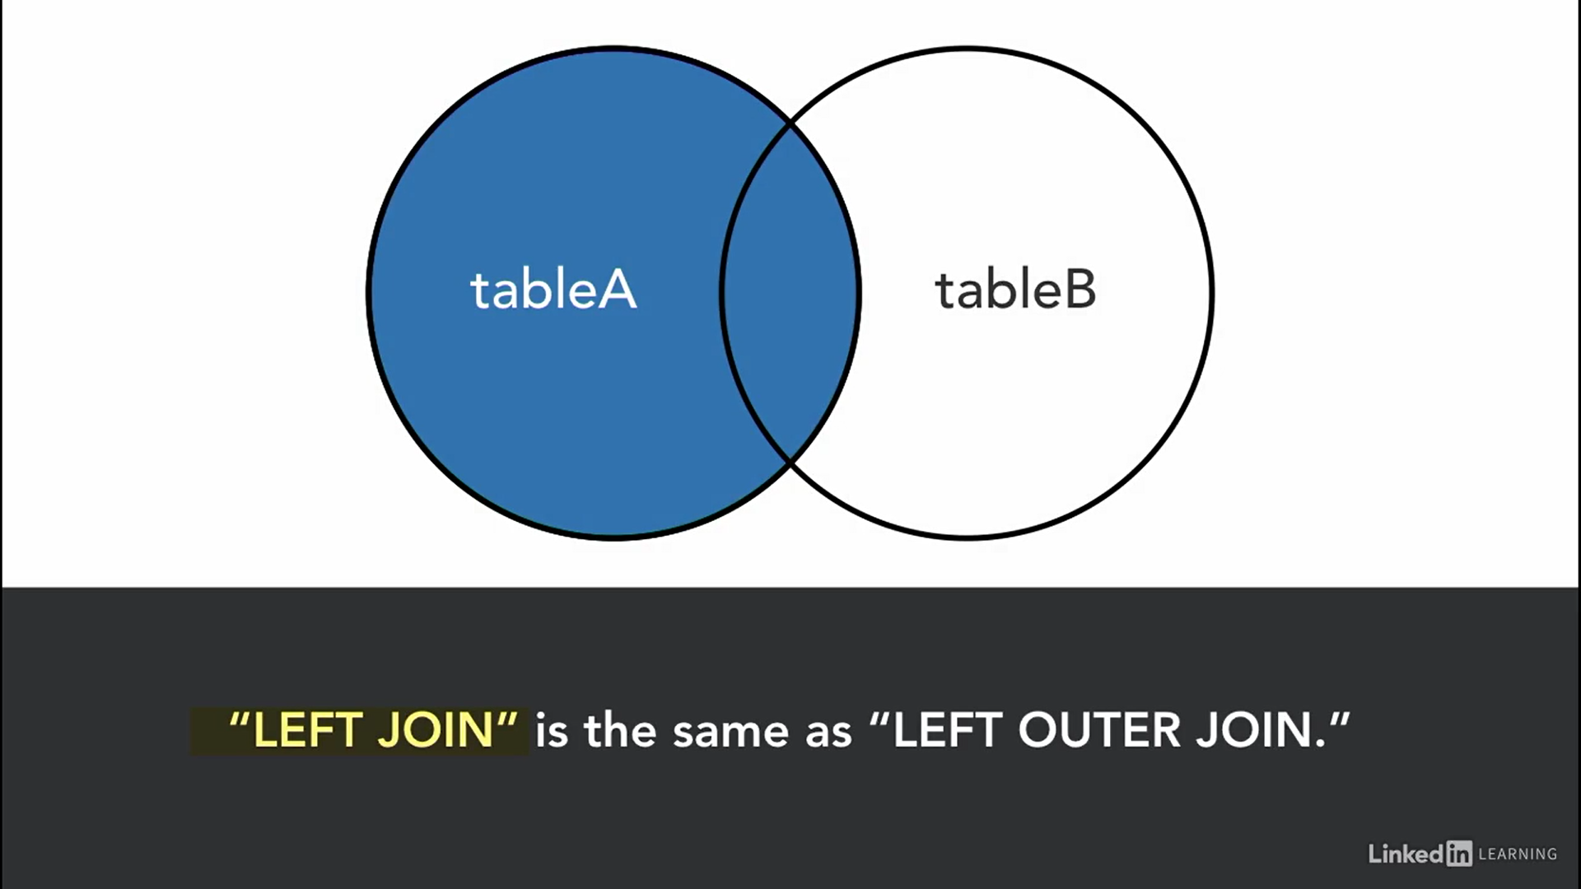

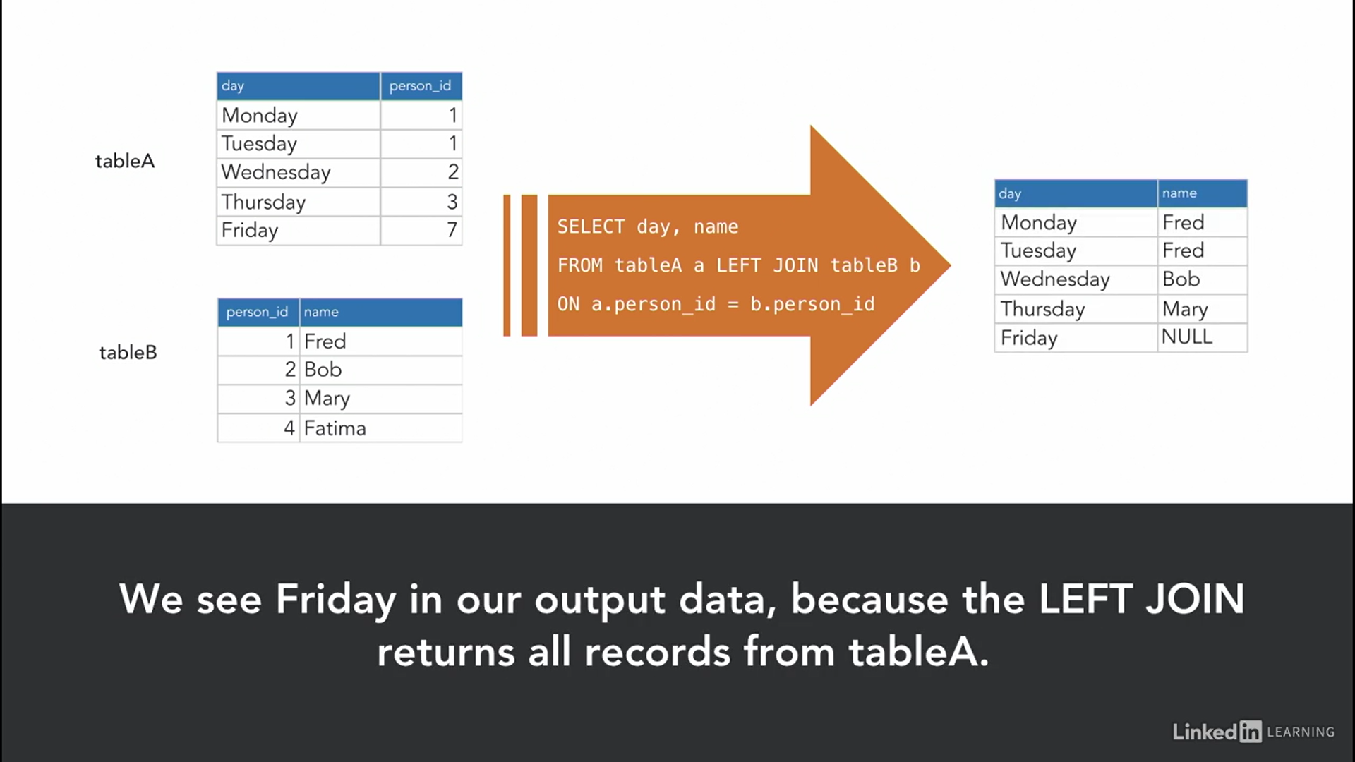

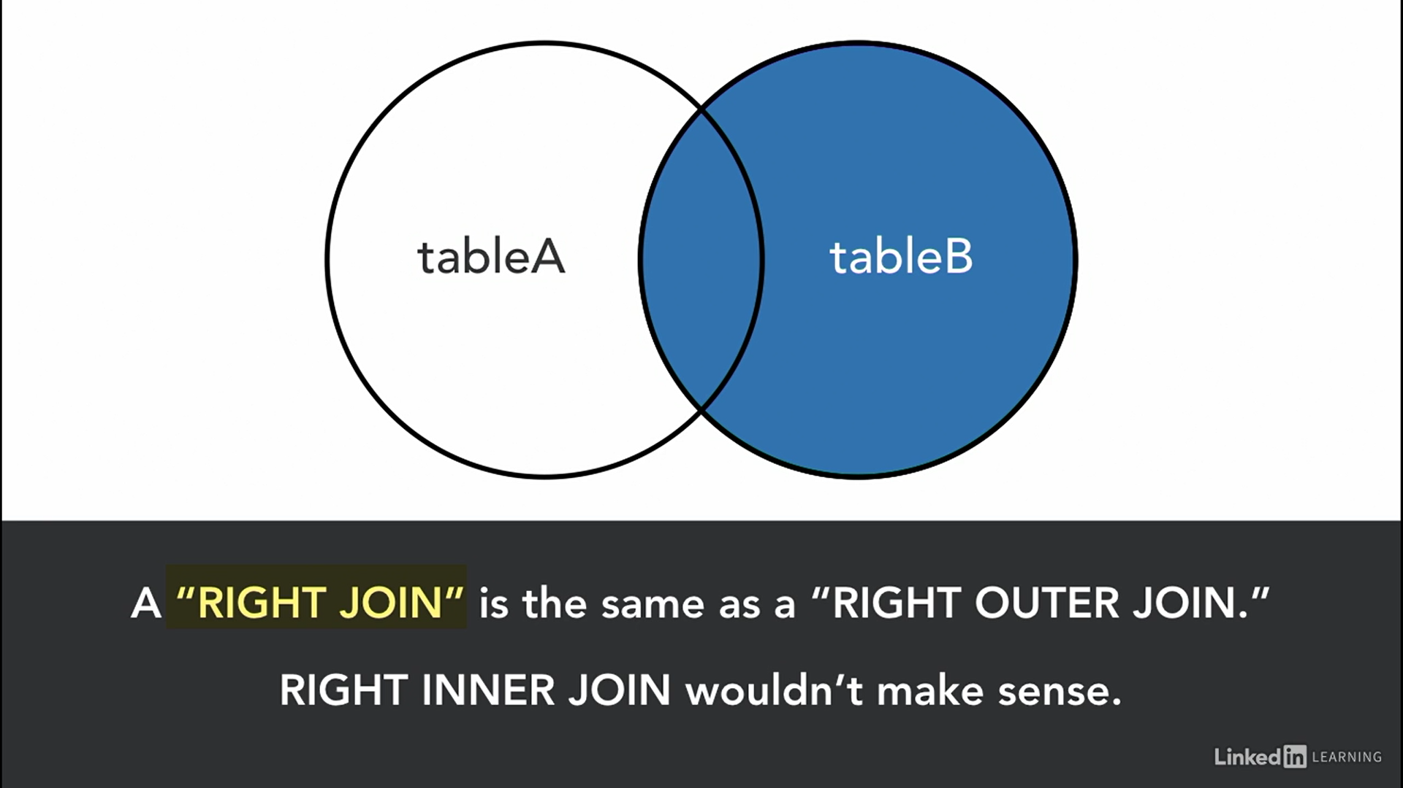

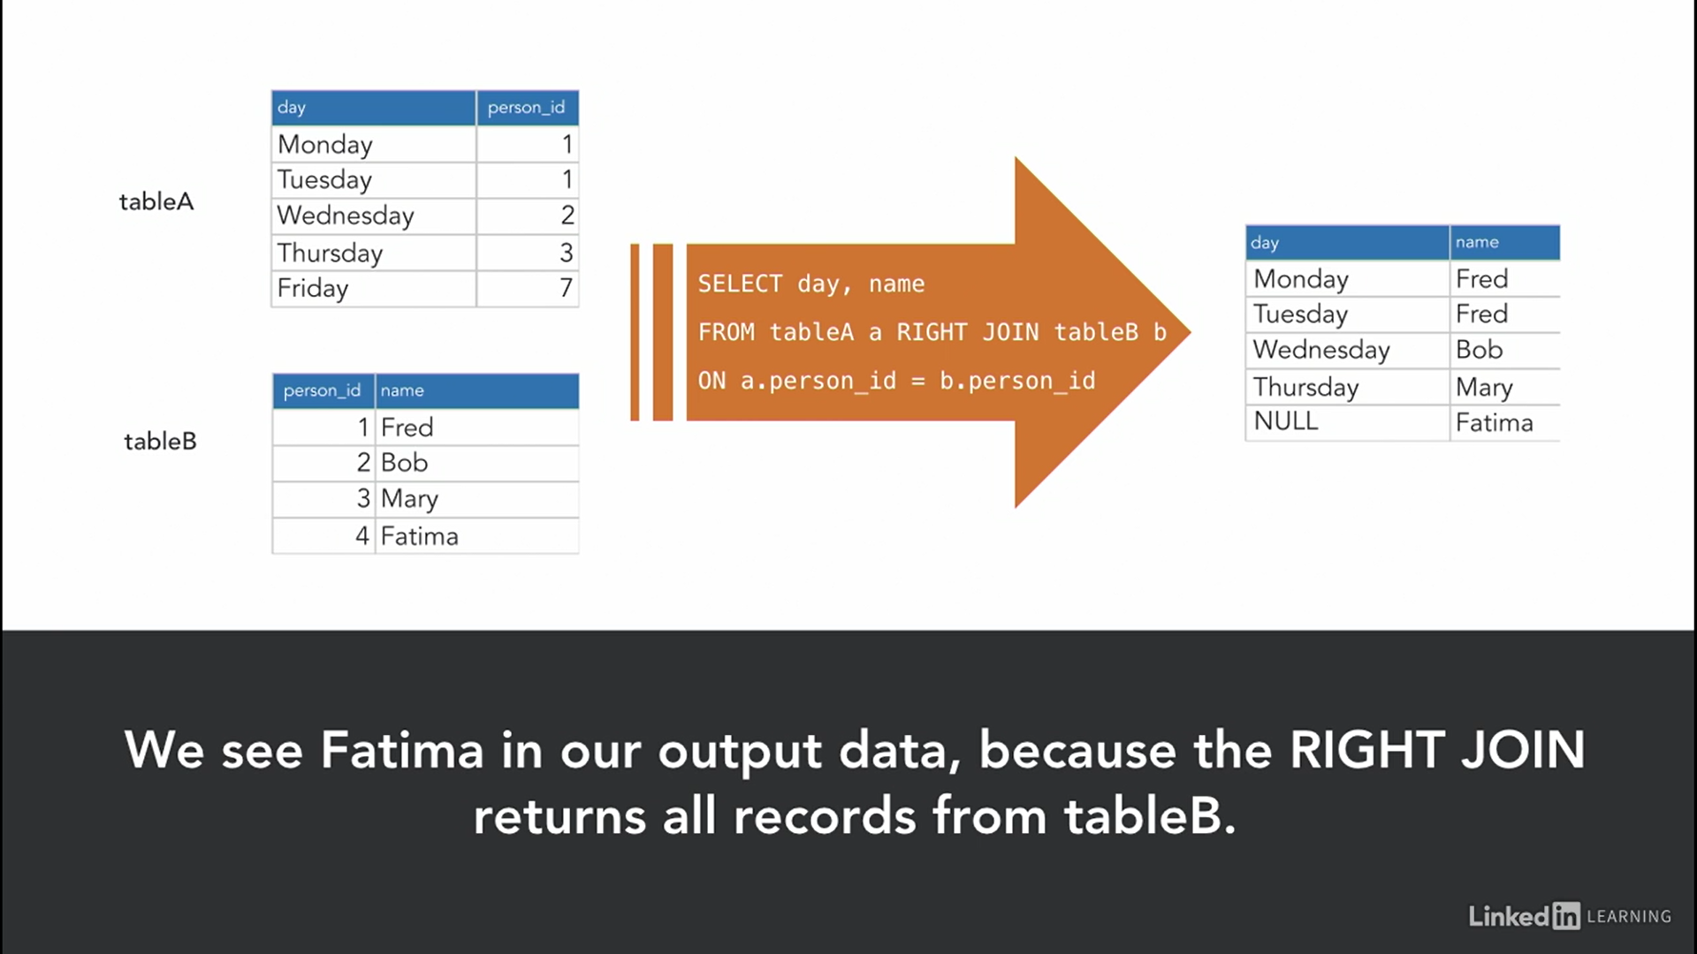

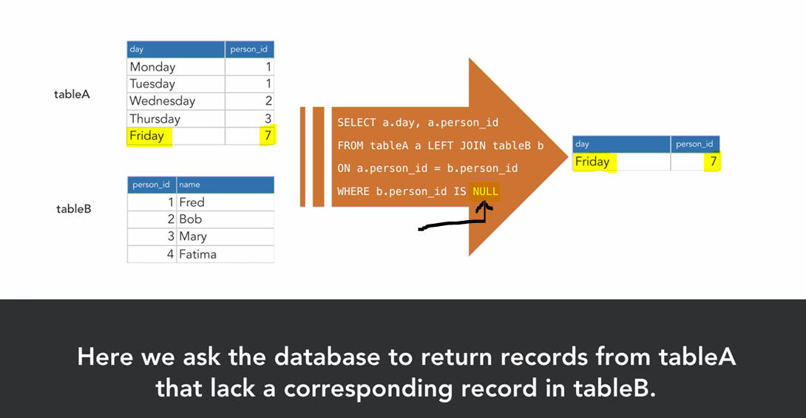

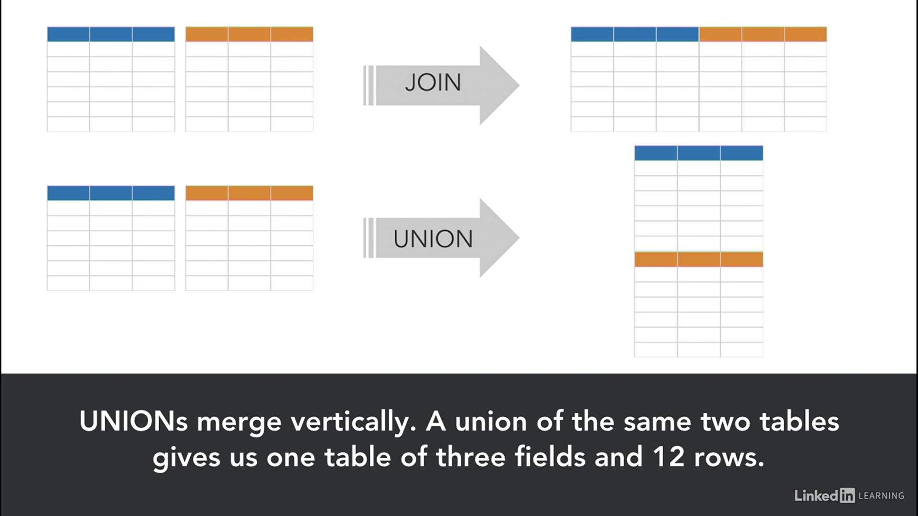

* If you want to keep the same values for the whole column – see the command in the below screenshot

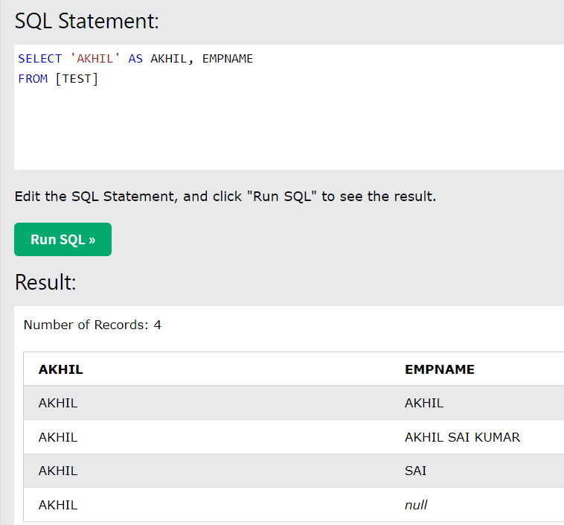

* When you do Union all (which appends the rows in 2 tables), ensure that you give column names (instead of *) or ensure that the tables in question have same number of columns

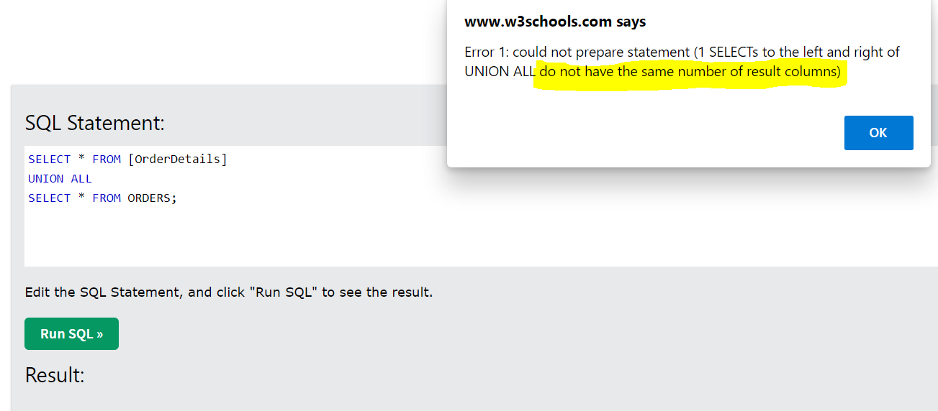

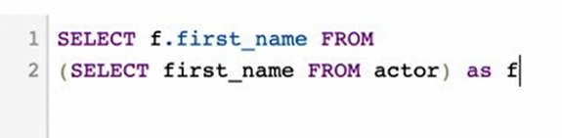

* If we run the below query, we will get an error, because, in the first select we mentioned ‘First name’ and in the sub-query, we actually renamed this column as ‘fn’

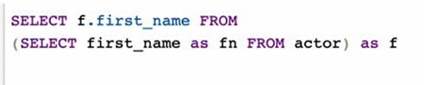

Use the below instead



* **View**: A View is a stored query
* **Variable**: It’s a user-defined keyword used to store data (a result set also)
* First we need to SET a variable and later use the same in the query – see screenshot below

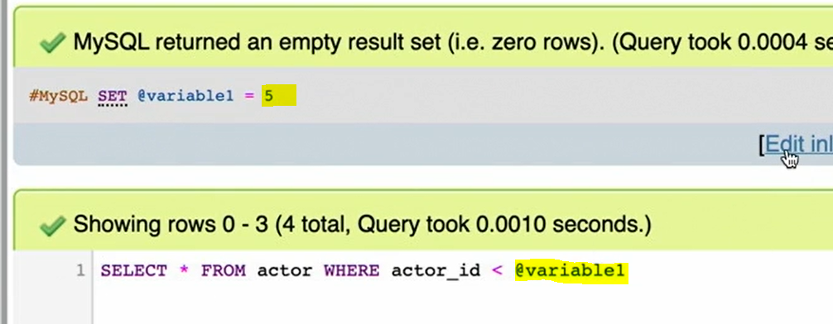

* # in the above screenshot is just a notes given to the query – doesn’t have any impact on the table and it wont even execute in any way
* **Structured Query Language** (SQL) is a common tool for retrieving data from relational databases such as SQL Server, MySQL, MariaDB, and PostgreSQL.
* DBMS, or Database Management Systems, is the process through which a Database is managed or controlled.
* **Database**: A collection of information, usually involving relationships b/w the data stored in it
* **Clauses** are basic components of Statements
* A **query** is a request for data or information from a database table or combination of tables.
* A **statement** is any text that the database engine recognizes as a valid command.
* **Predicates** are the conditions and expressions represent values. Ex. Where colname = ‘CA’. CA is the predicate
* **Arguments** are something that you specify in functions’ braces (ex. In SUBSTR, there are 3 arguments we can place)
* The SQL PRIMARY KEY constraint combines between the UNIQUE and SQL NOT NULL constraints, where the column or set of columns that are participating in the PRIMARY KEY cannot accept a NULL value. If the PRIMARY KEY is defined in multiple columns, you can insert duplicate values on each column individually, but the combination values of all PRIMARY KEY columns must be unique.
* A FOREIGN KEY is a field (or collection of fields) in one table, that refers to the PRIMARY KEY in another table to create a way of cross-referencing the two tables.
* **Entity**: An entity is a real-world thing which can be distinctly identified like a person, place or a concept.
* **Strong Entity**: The strong entity has a primary key. Weak entities are dependent on strong entity. Its existence is not dependent on any other entity. Strong Entity is represented by a single rectangle.
* **Weak Entity**: The weak entity in DBMS do not have a primary key and are dependent on the parent entity. It mainly depends on other entities. Weak Entity is represented by double rectangle.
* **Types of Dependencies:** 
  + **Functional Dependency**: If the information stored in a table can uniquely determine another information in the same table, then it is called Functional Dependency. If EmpID functionally determines EmpName, then, **Empid -> EmName**
  + **Fully-functionally Dependency**: An attribute is fully functional dependent on another attribute, if it is Functionally Dependent on that attribute and not on any of its proper subset.
  + **Partial Dependency**: Partial Dependency occurs when a nonprime attribute is functionally dependent on part of a candidate key.
  + **Transitive Dependency**: When an indirect relationship causes functional dependency it is called Transitive Dependency. If P -> Q and Q -> R is true, then P -> R is a transitive dependency.
* **DML**: Edit data in the databases and also to CRUD records (CRUD = Create, Read, Update and Delete). Create in this acronym is inserting values in the table, Read is select/access the data, Update is using UPDATE statement using Set and Where and D is for Delete
* **DDL**: Edit the structure (schema) of the database and to add, change or remove fields or tables
* A record (or a row) represents the information of a single data entity.
* Clauses are defined by the keywords in the statement, which are SELECT, FROM, WHERE, and ORDER BY.
* A schema is made of tables and the relationships between the tables.
* SQL originally called SEQUEL (Structured English Query Language)
* SQL first into use in 1974 and it became standard in 1986

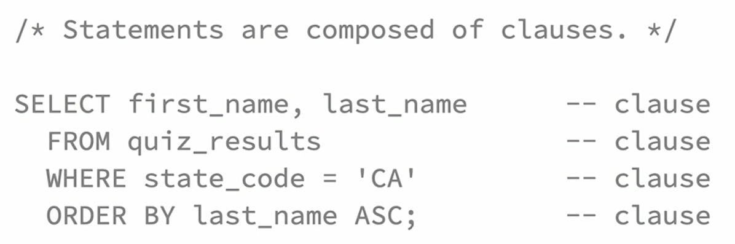

* Select statement does not necessarily returns everything from database, we can still use it to display the explicit text

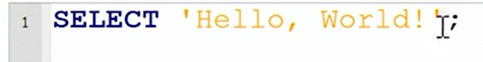

* Single quotes are for literal text, not for columns
* Select is used to Read the data and this is the R in CRUD acronym
* Where keyword lets us add selection criteria to a statement
* **Operator and Operand**: An operation is an action performed on one or more values either to modify the value held by one or both of the values, or to produce a new value by combining values. Therefore, an operation is performed using at least one symbol and one value. **The symbol used in an operation is called an operator. A value involved in an operation is called an operand.**

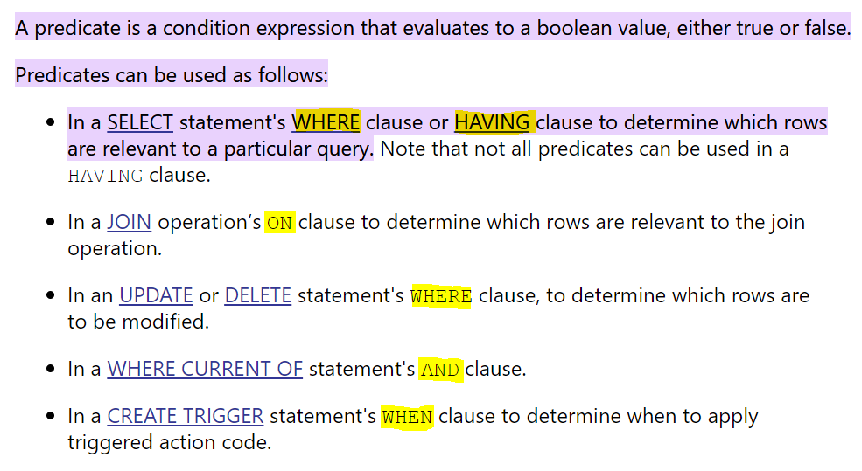

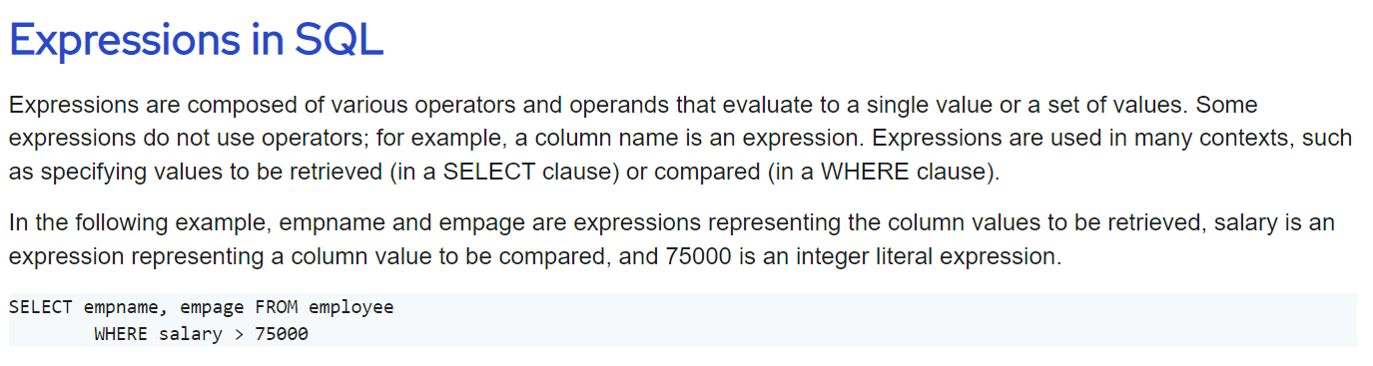

* In the below Where predicate/condition, CA is an Expression



* “=” and “IS” are same and **<>, !=** and **IS NOT** are same
* In Limit clause, we can also specify the no. of records after which we would like to see the results – Use offset keyword (it will get values from 11th record of the results)

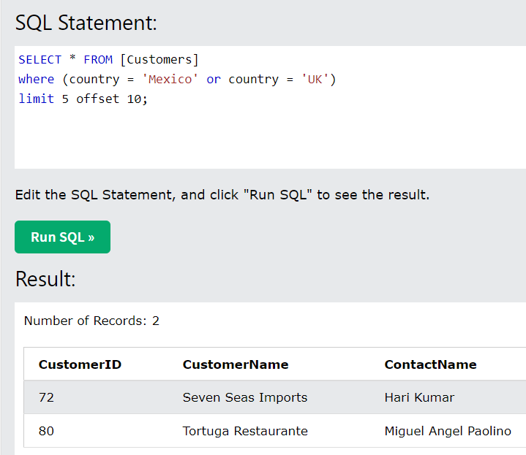

* Count will not consider null values (it gives us the non-null count of the rows)
* In the Count function if you use the column that has null values Vs the column that has full values, you will see difference

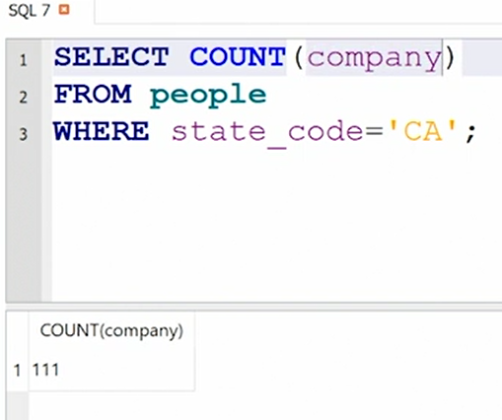

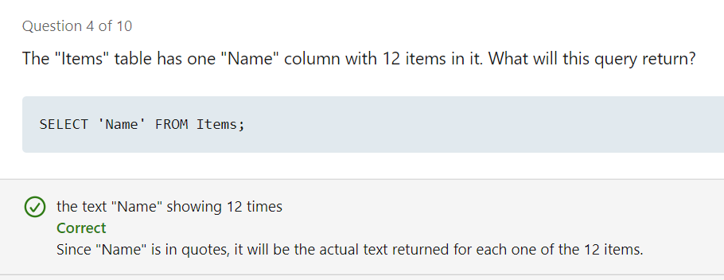

* When we do **not** specify pk and fk relation in join condition, then we will get more data (left table records count * right table records count) -

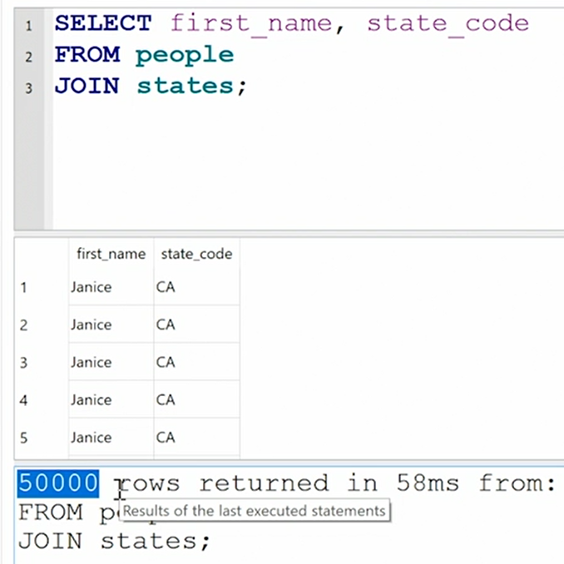

* **Implicit Join**: Where we don’t specify the JOIN condition in the command

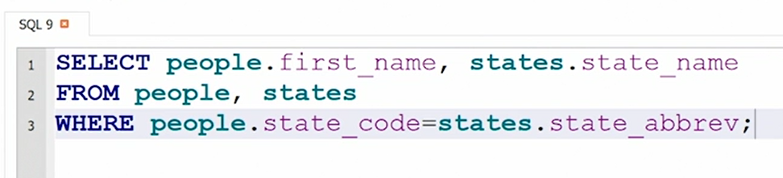

1. Types of Join:

* **Cross Join**: Cartician Product (we will get more data i.e. left table records count * right table records count)
* **Inner Join/Join:** An inner join only returns matches for items in the left table that are also found in the right table.
* **Left Join/Left Outer Join**
* **Right Join/Right Outer Join**
* **Full Outer Join**

**On** expression in Join condition doesn’t have any impact

Grouping by two fields is possible by adding both fields in the same GROUP BY clause.

* Below screenshot is the improper use of Count function (with no Group By function)

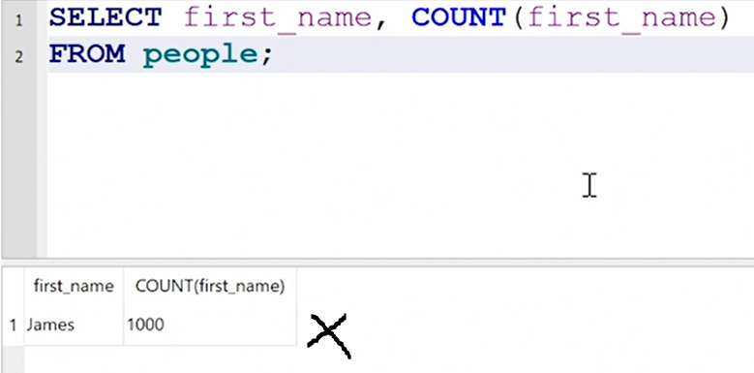

* Correct usage of Count function (with group by function)

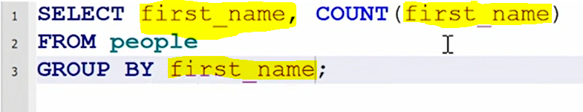

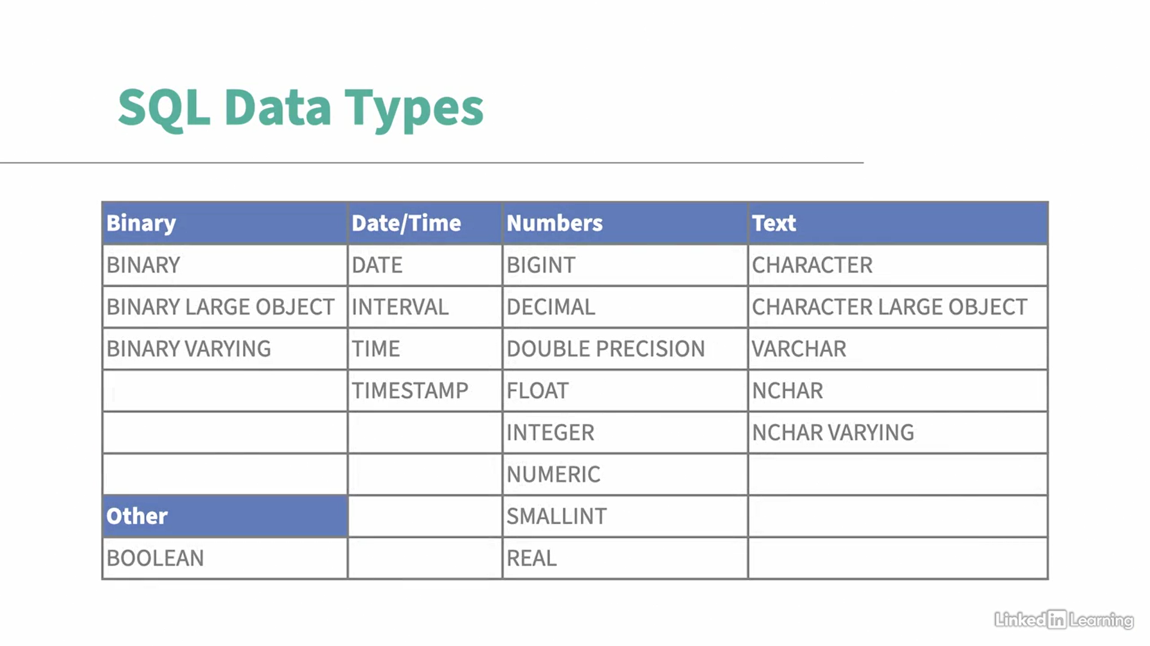

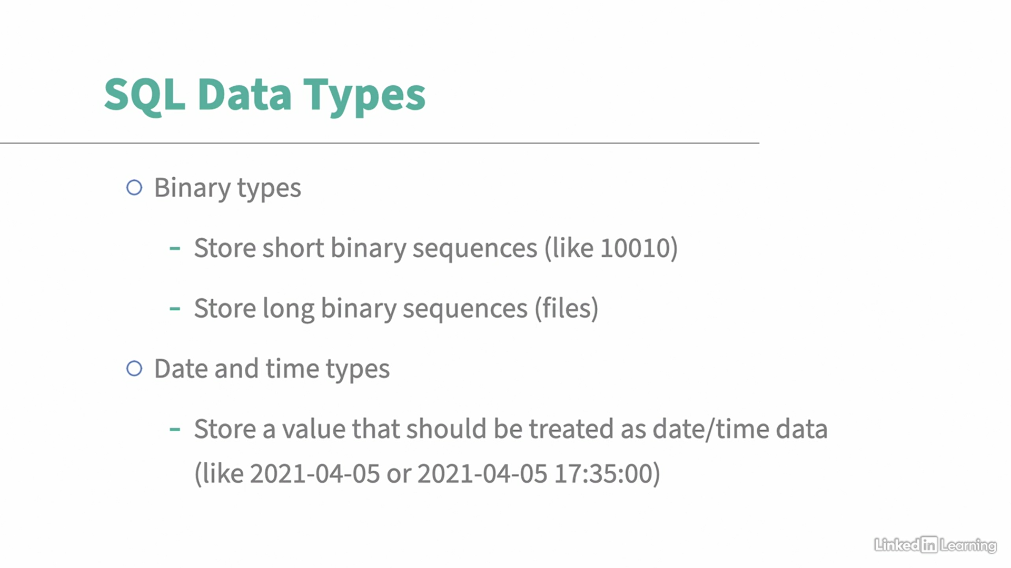

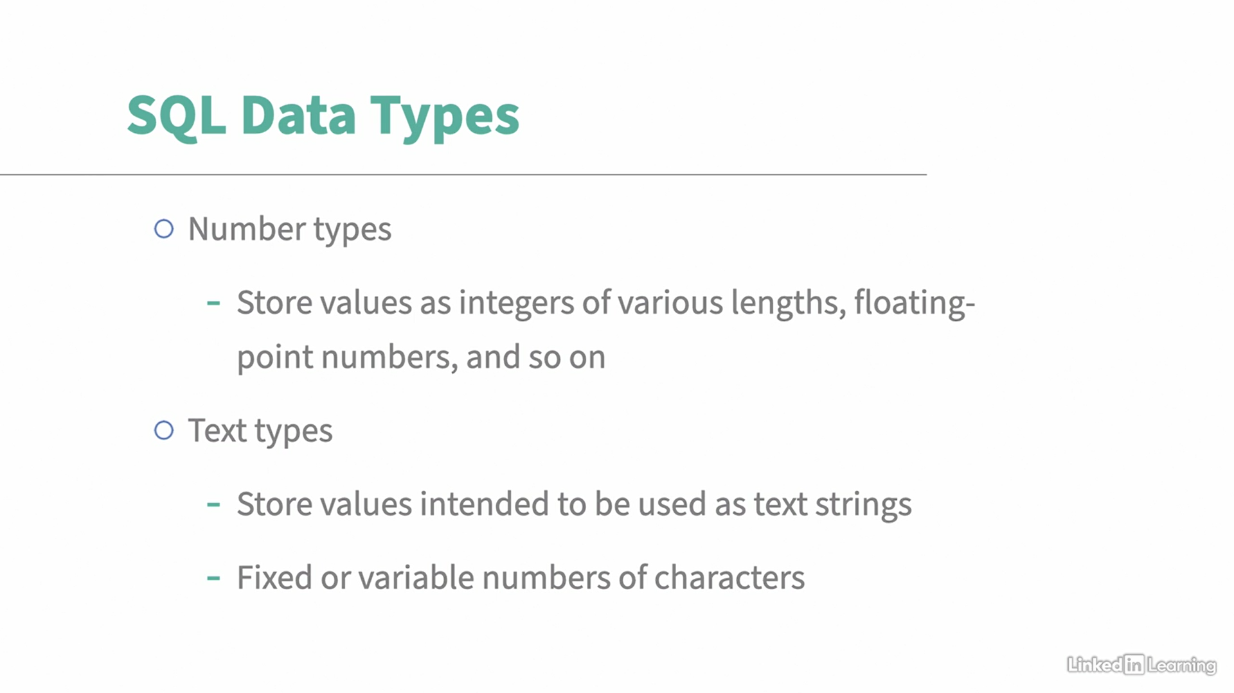

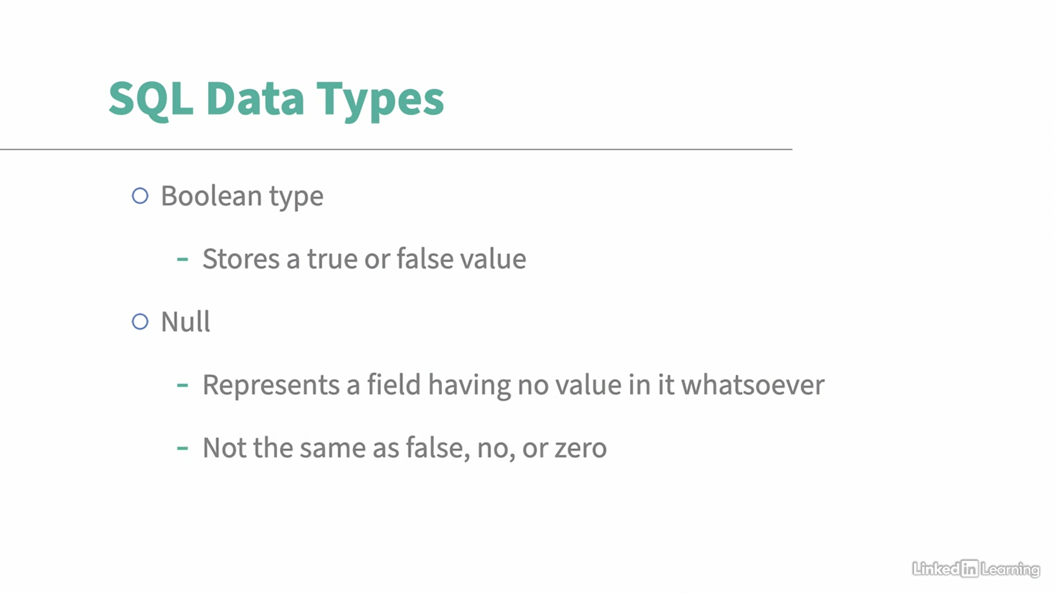

* Sub-query or sub-select or compound select
* Replace function: The A in the below replace argument is case-sensitive



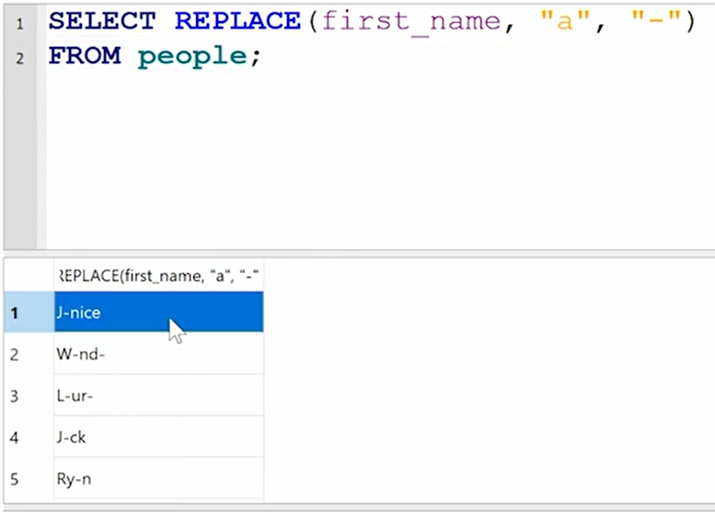

* The below is the incorrect way of inserting values (as we didn’t give last name to Carol) – use NULL after carol, if you don’t want to show or don’t have last name

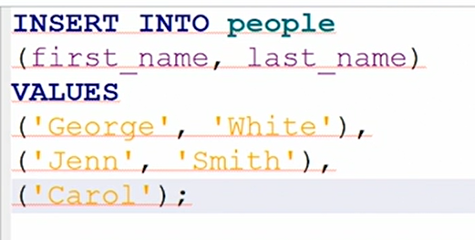

* Table is a two-dimensional grid that consists of rows/instances/records and columns/fields/variables/attributes (which describes something about the row)
* SQL is a primary language that we use to manage structured data from relational databases
* DBMS: A software application that helps us store, load, retrieve and update data in the d/b
* According to Stackoverflow insights, SQL is the 3rd widely used language after Javascript and HTMS/CSS
* Relational Database: Where we have unique entities and a relation b/w those entities - A relational database is a type of database that stores and provides access to data points, or entities, that are related to each other.

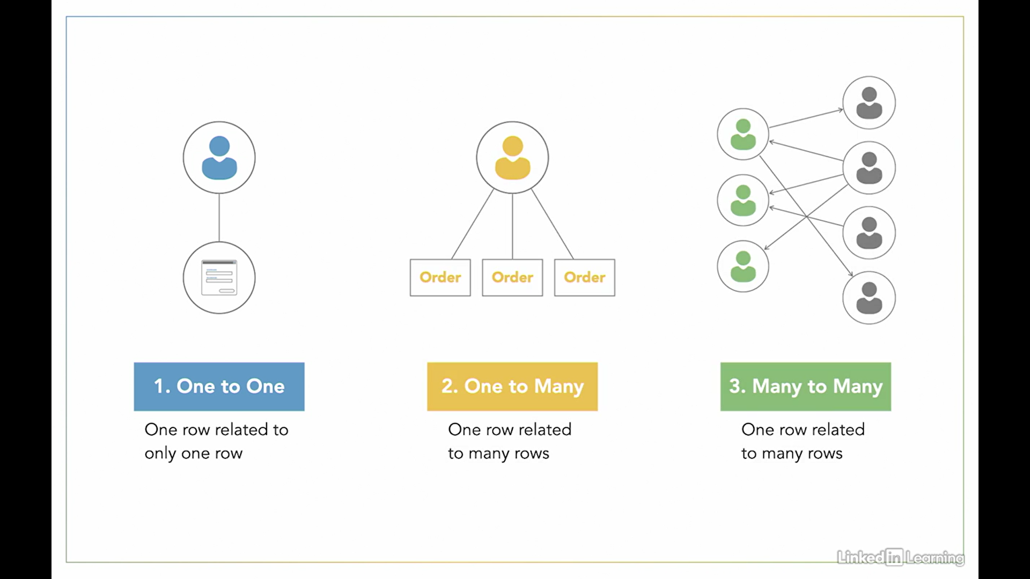

* Entity-Relationship Diagram/Model: Graphical representation of entities and their relationships to each other
* Referential Integrity: Each Foreign Key is a reference to a PK

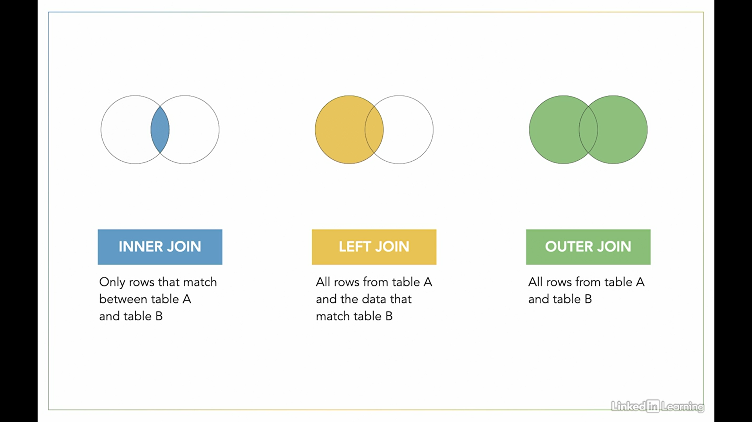

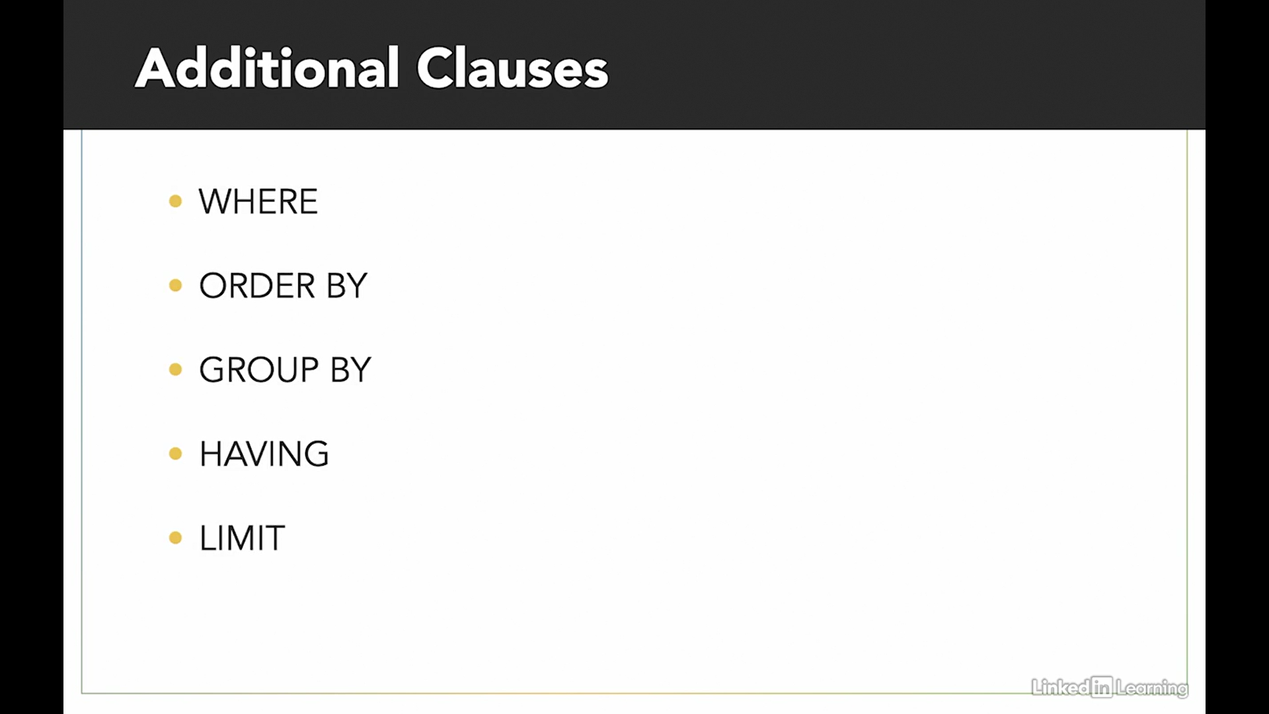

* Data type of a column defines what value the column can hold

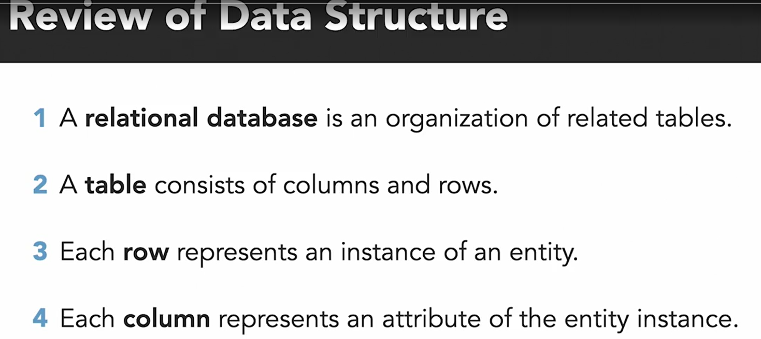

* Column Constraints: Specifies rules for the data at the column level

1. Not or Not null
2. Unique
3. PK and FK
4. Default

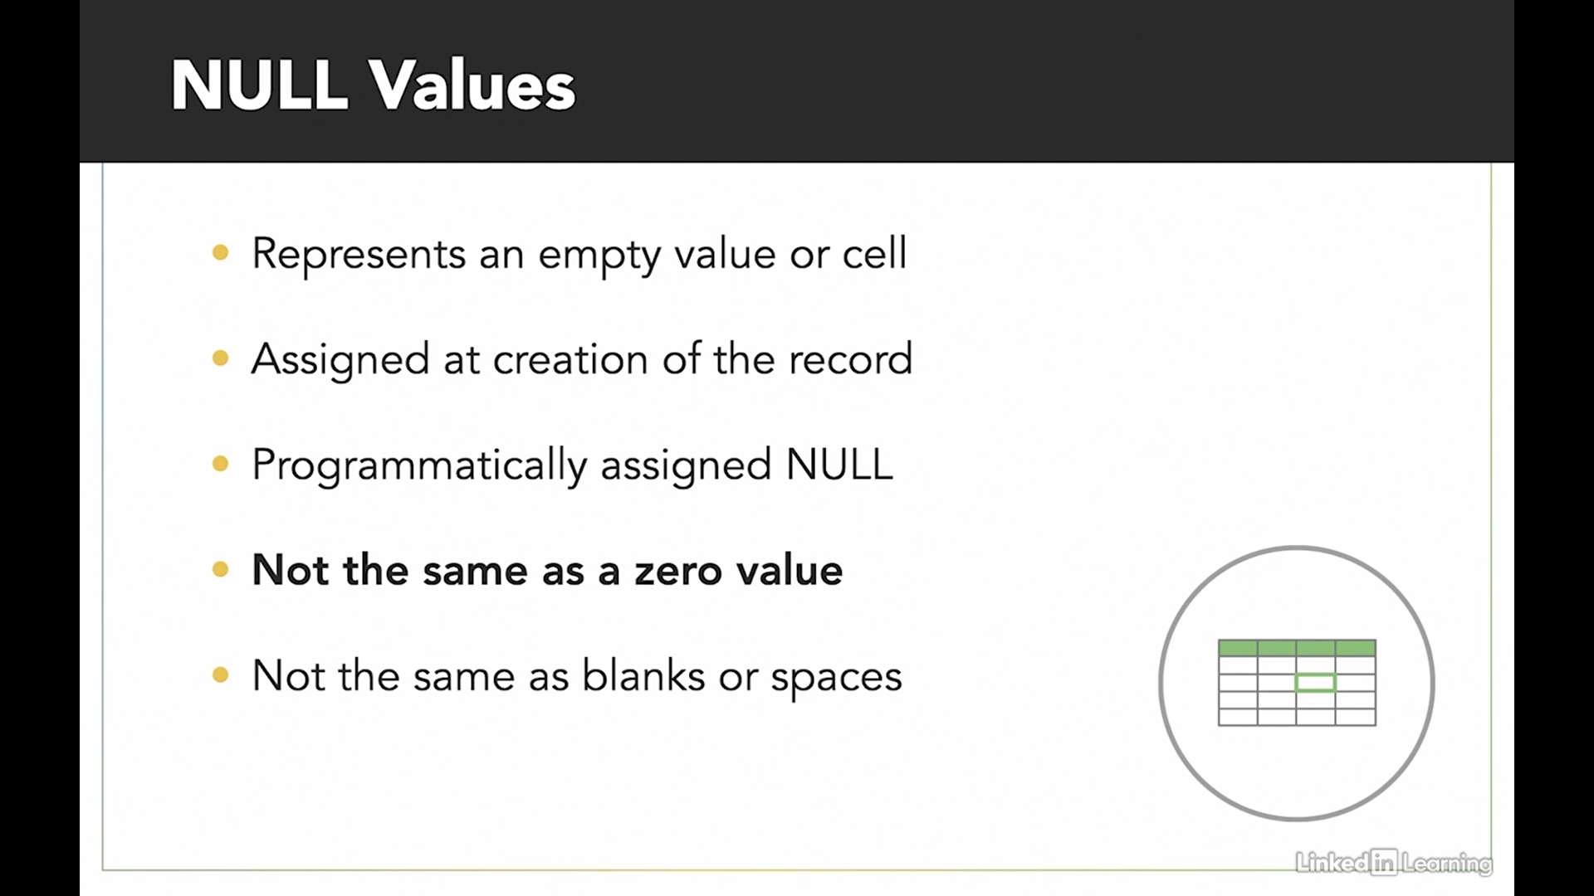

* 3 main types of Operators

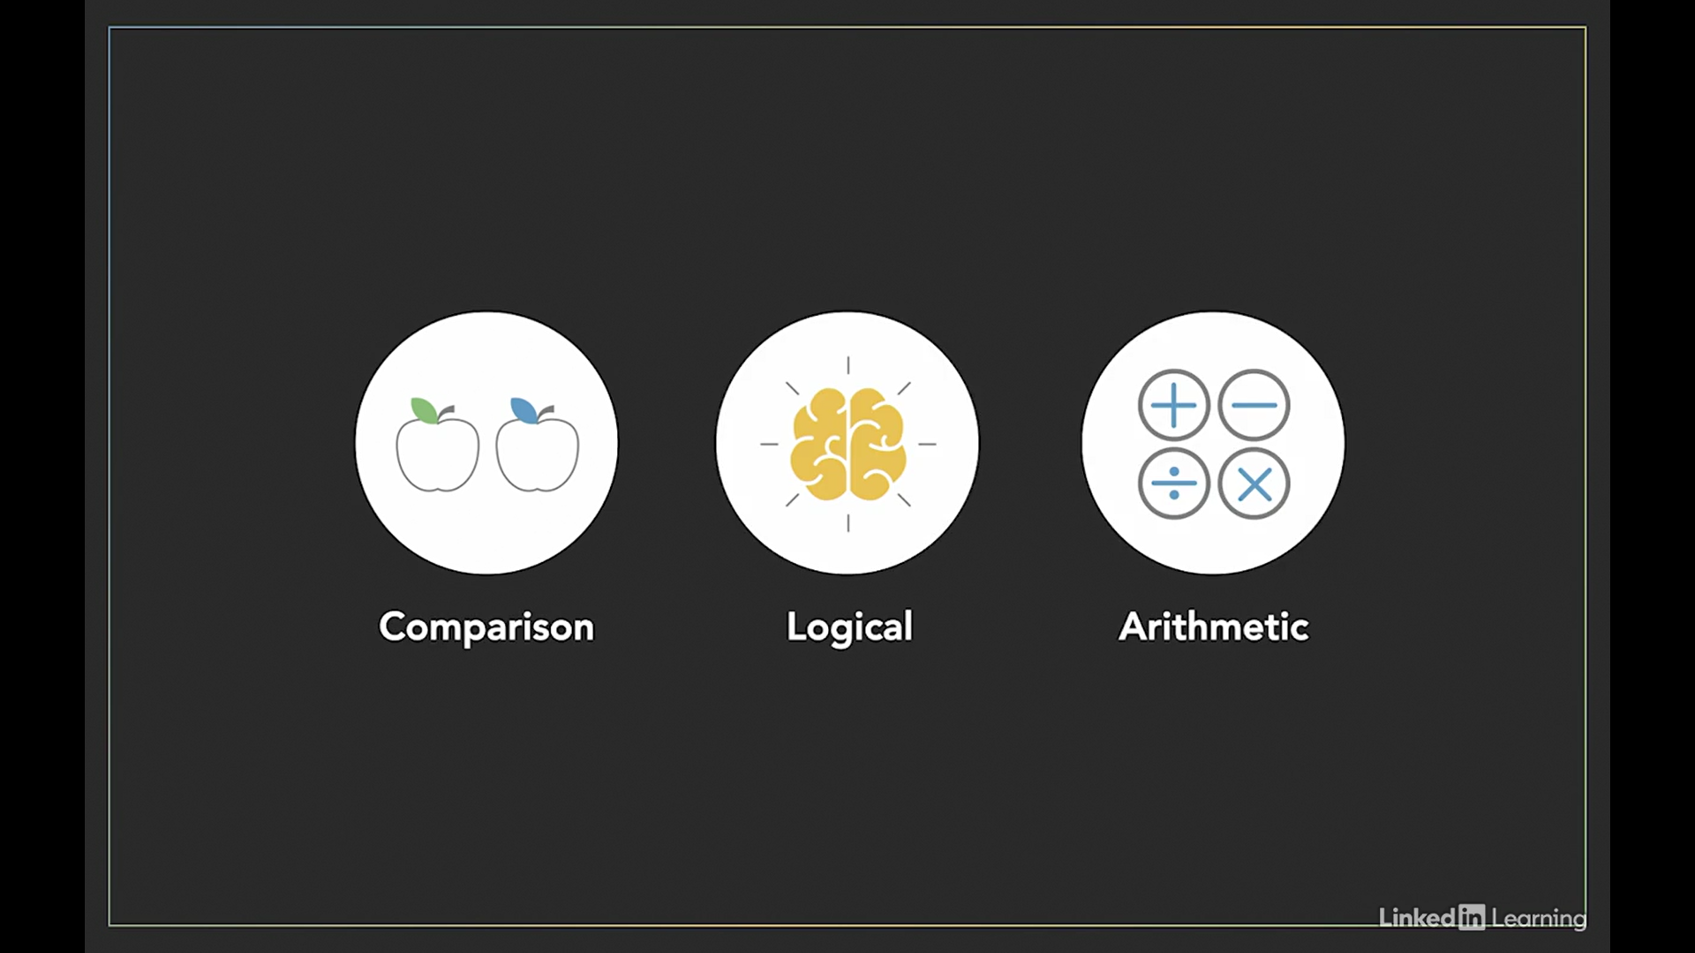

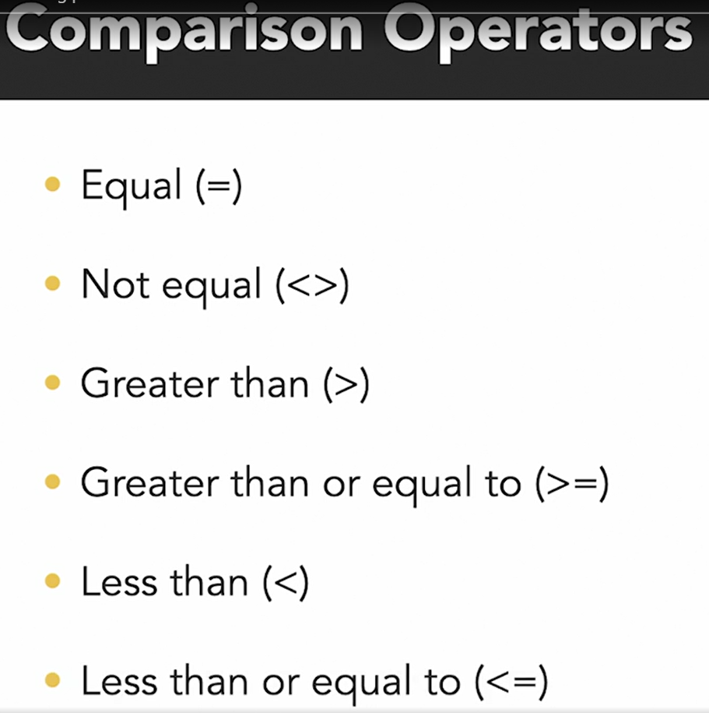

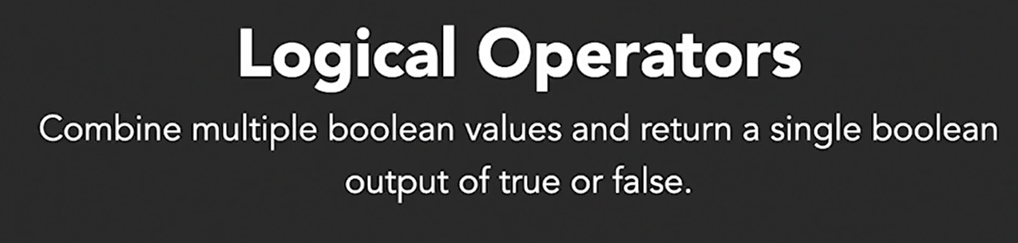

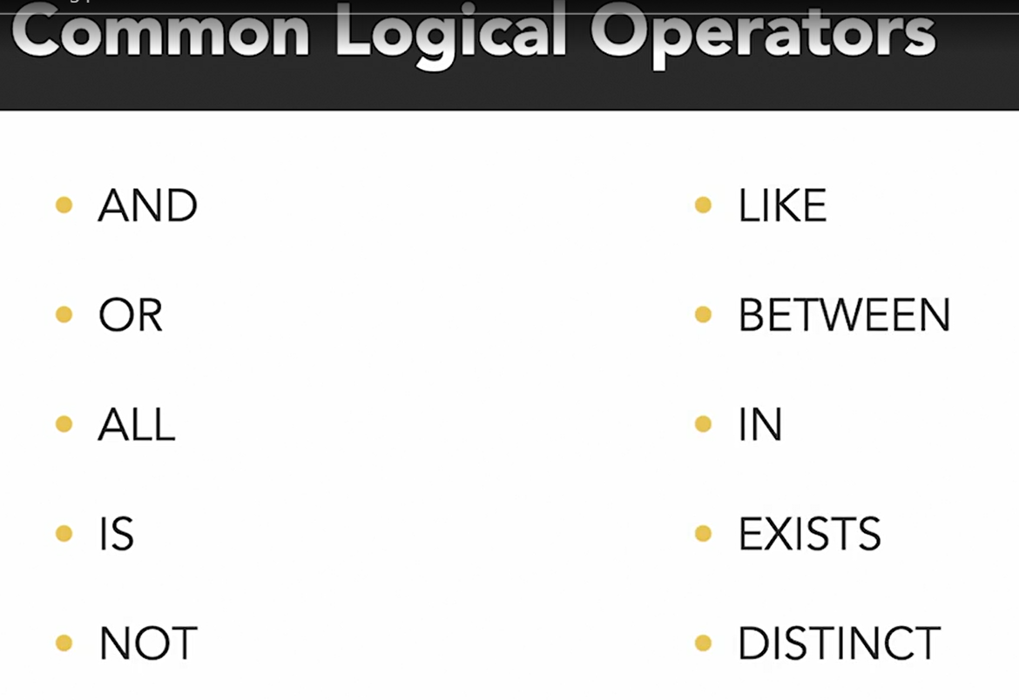

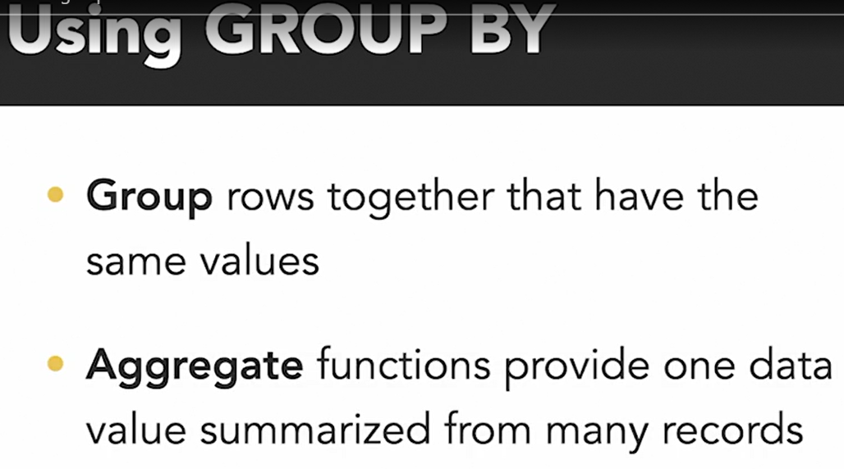

HAVING clause always comes after the Group By

All the fields in the Select statement should also be in the Group By

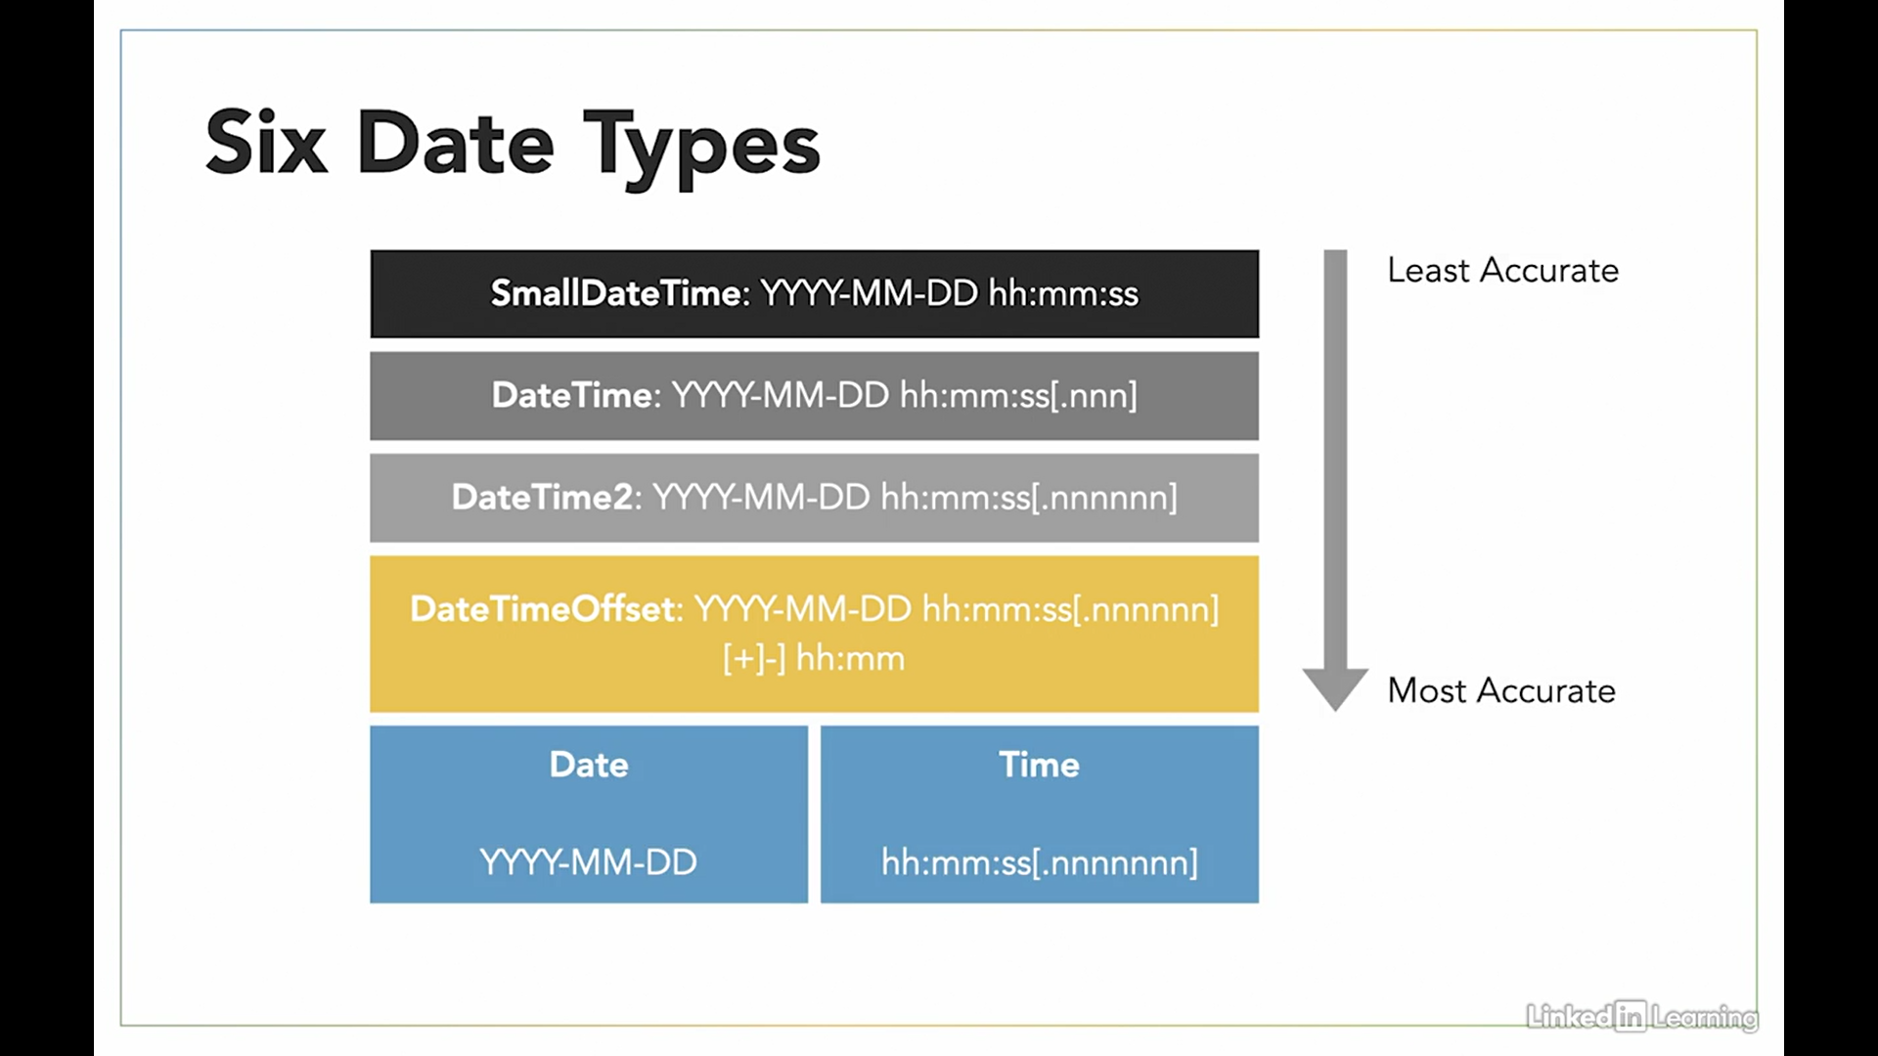

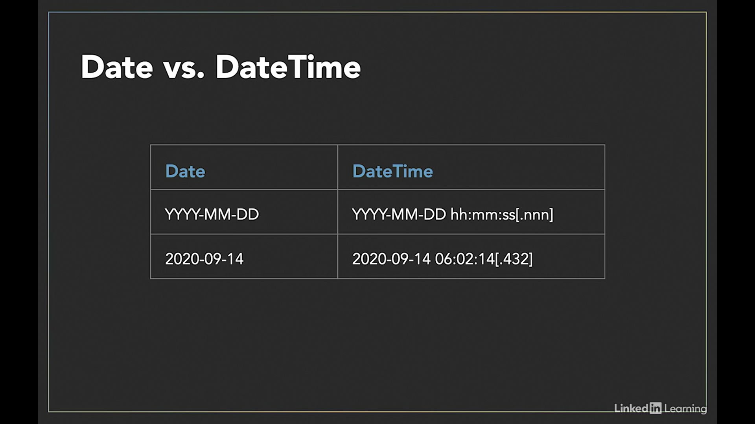

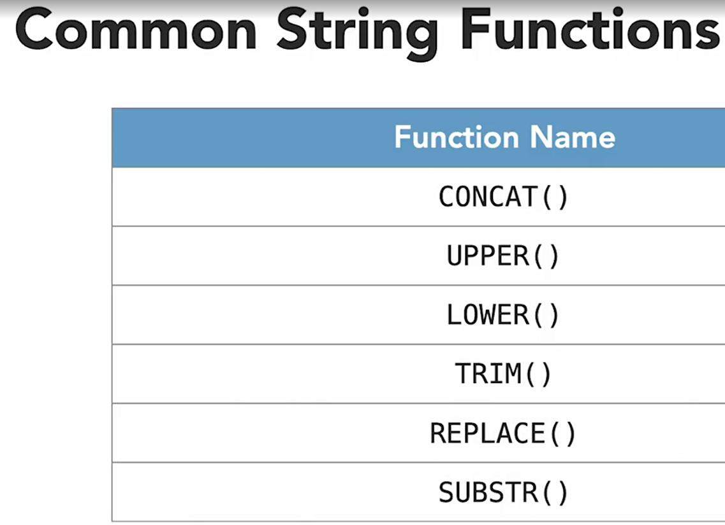

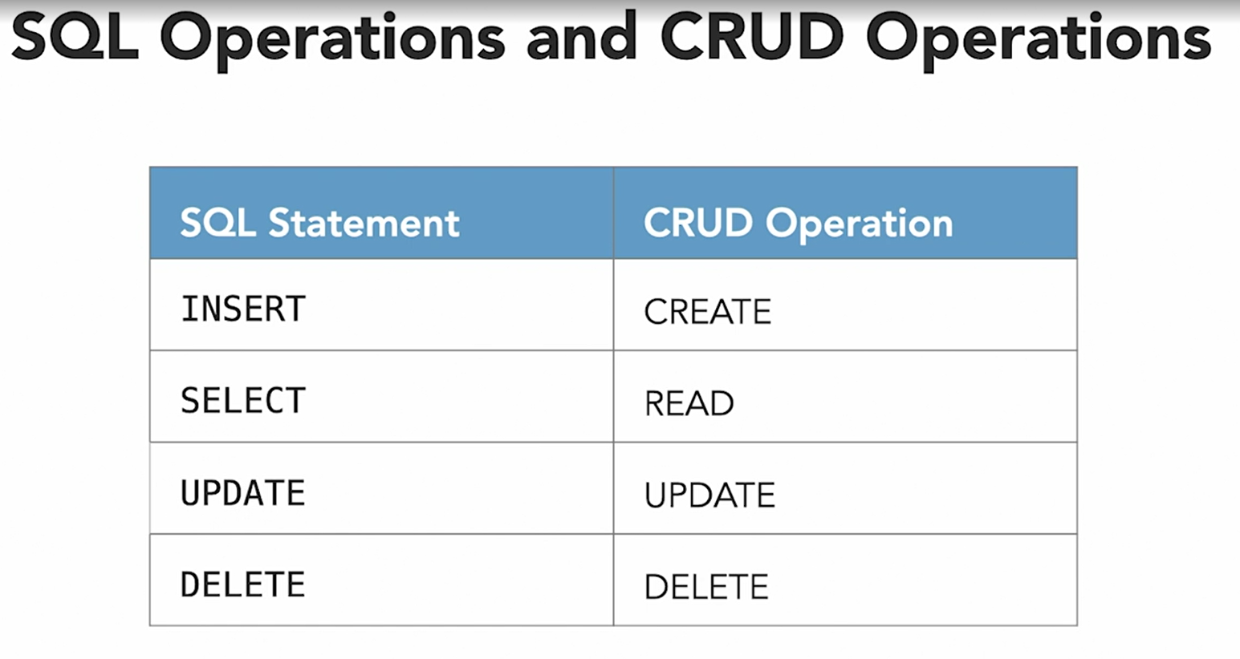

The outer and inner queries can get data from different tables within a database. The result of the subselect query is used as input for the outer query

Tables physically store data, but views are considered virtual tables created to retrieve data from one or more tables present in a database.

Tables are created with the CREATE TABLE statement and views are created with the CREATE VIEW statement.

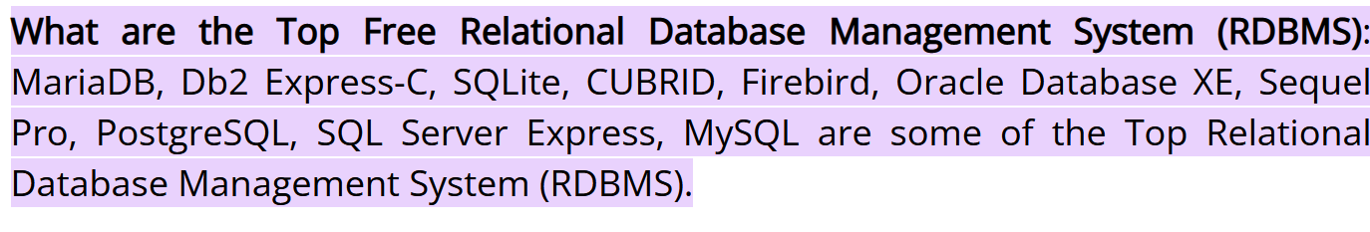

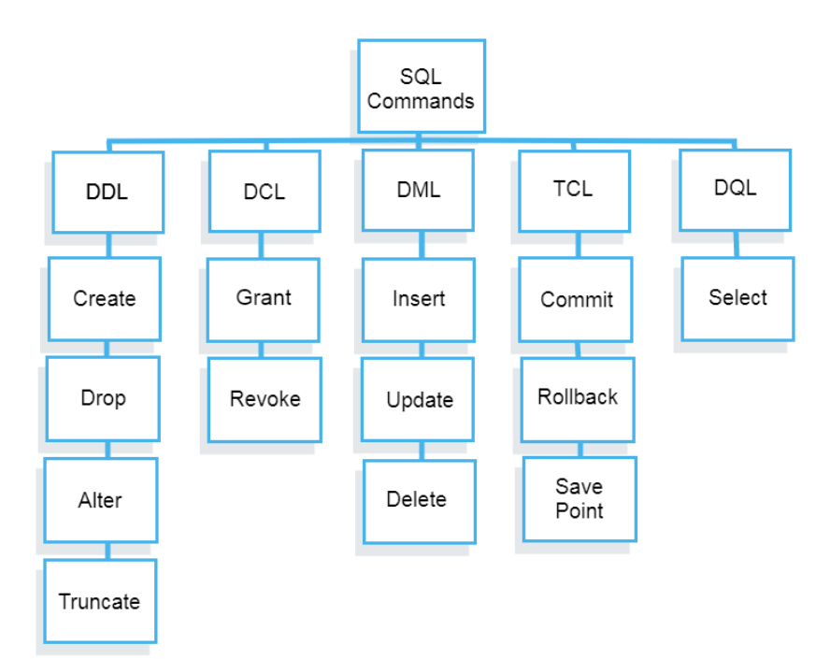

**TCL**: Transaction control language or TCL commands deal with the transaction within the database.

* **Commit**: This command is used to save all the transactions to the database.
* **Rollback**: Rollback command allows you to undo transactions that have not already been saved to the database.
* **SavePoint**: This command helps you to sets a savepoint within a transaction. It creates points within the groups of transactions in which to ROLLBACK. A SAVEPOINT is a point in a transaction in which you can roll the transaction back to a certain point without rolling back the entire transaction.
  + Syntax:

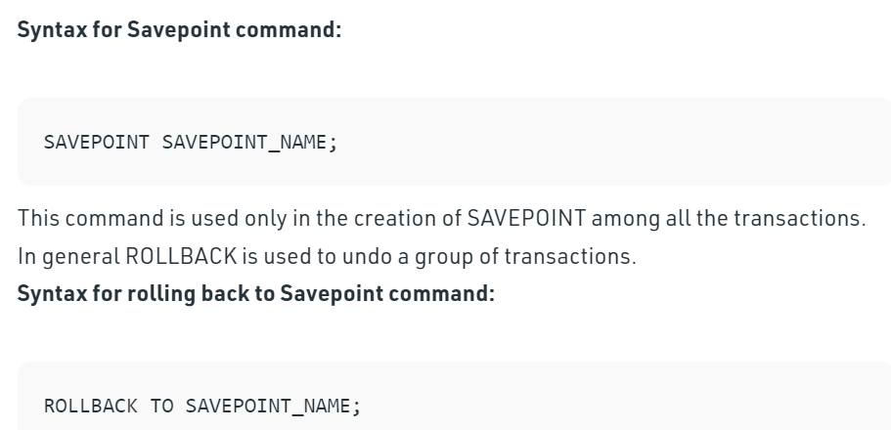

In the year 1974, the term Structured Query Language appeared.

**Having:** “[HAVING condition]” is optional; it is used to restrict the rows affected by the GROUP BY clause. It is similar to the WHERE clause.

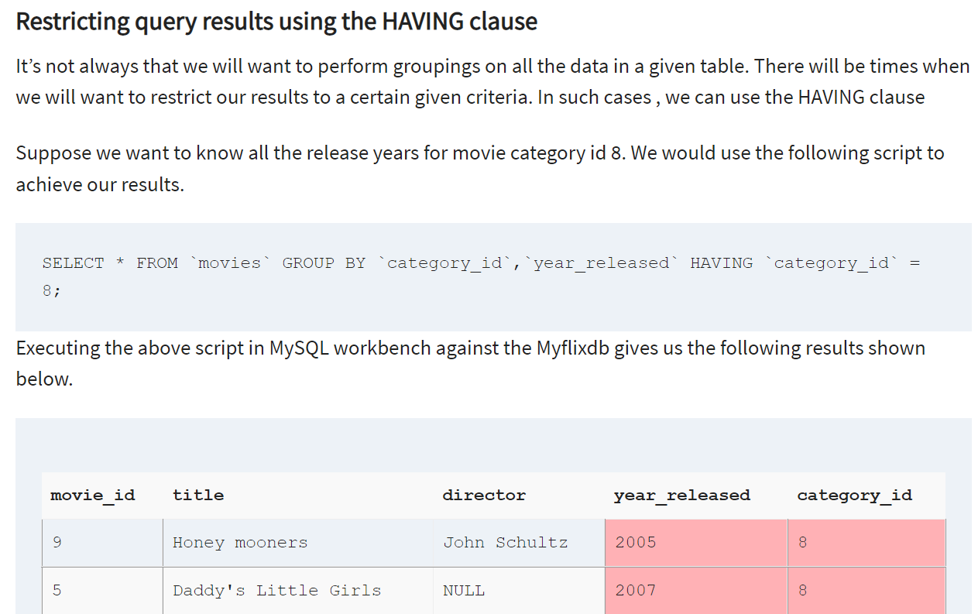

A Query is a set of instruction given to the database management system. It tells any database what information you would like to get from the database.

* **Types of SQL Functions**: https://whatisdbms.com/different-sql-functions-with-examples/

<https://www.w3schools.com/sql/sql_ref_mysql.asp>

<https://www.w3schools.com/sql/sql_ref_keywords.asp>

**On a broader category, there are two types of functions:-**

**Single Row functions** - Single row functions are the one who work on single row and return one output per row. For example, length and case conversion functions are single row functions. **ETR**: NASDaC Stock exchange

1. ***Numeric/Arithmetic Functions***: Accepts numeric input and returns numeric values. Functions under the category are ROUND, TRUNC, and MOD.

* **Round**: Rounds value to specified decimal
  + - **Syntax**: Select ROUND (433.337,2) – **Result: 433.34**
* **Trunc**: Truncates values to specified decimal (without consideration for the rounding off)
  + - **Syntax**: Trunc (433.337,2) – **Result: 433.33**
* **Mod:** Returns reminder of division
  + - **Syntax**: Mod (1600,300) – **Result: 100**
  + **ABS**: used to return the absolute/positive value of a specified number
    - **Syntax**: SELECT ABS(-0.7) – **Result: .7**
  + **Floor**: Returns the largest integer value which is less than or equal to a number.
    - **Syntax**: SELECT FLOOR(21.53) – **Result: 21**
* **Ceiling**: returns the smallest integer value which is greater than or equal to a number.
  + - **Syntax**: SELECT CEILING(21.53); - **Result: 22 (**when argument is -ve, then 21**)**

1. ***Aggregate Functions***:

* **AVG**: calculates the average of a set of values
  + - **Syntax**: Select AVG (colname)
* **Count**: counts rows in a specified table or view
  + - **Syntax**: Select SUM (colname)
* **MIN:** gets the minimum value in a set of values
  + - **Syntax**: Select MIN (colname)
  + **MAX**: gets the maximum value in a set of values
    - **Syntax**: Select MAX (colname)
  + **SUM**: calculates the sum of values
    - **Syntax**: Select SUM (colname)

1. ***String Functions***:
2. **Character Conversion Functions**: EX: ***UPPER, LOWER & INITCAP*** (initial character will be capital and rest is small) – These can be used either on tables or on any strings as well – INITCAP is not a function in MySQL
3. **Character Manipulation Functions**: EX: CONCAT/||, SUBSTR, LENGTH, INSTR, LPAD, RPAD etc – These are used for reporting purposes only

* **SUBSTR:** Substring – it’s a part of string – it takes 3 parameters (refer screenshot below) – 1st is the string from which you want to extract the part, 2nd is the starting point from where you want to extrack and 3rd parameter is the no. of characters that you want to extract - This function is used to find a sub string from the a string from the given position.
* **Syntax**: SUBSTR('geeksforgeeks', 1, 5);
* **Output**: ‘geeks’
* **INSTR:** In string – whether a particular character is present in the string – it has 2 parameters (refer screenshot below) - This function is used to find the occurrence of an alphabet
* **Syntax**: INSTR('geeks for geeks', 'e', 1, 2 );
* **Output**: 3 (the second occurrence of ‘e’)
* **LPAD:** it has 3 parameters (the conditions mentioned in the braces) – 1st parameter is String/Attribute – 2nd parameter is the size of the character you want and 3rd parameter is something what should be filled in the vacant positions - This function is used to make the given string of the given size by adding the given symbol.
* **Syntax**: LPAD('geeks', 8, '0');
* **Output**: 000geeks
* **Length:** it takes only 1 parameter - This function is used to find the length of a word.
* **Syntax**: LENGTH('GeeksForGeeks');
* **Output**: 13
* **LPAD:** Left aligns the data – 3 parameters – 1ST is the attribute name, 2nd is the max length of the attribute, 3rd is specify the character which has to be padded/added
* **RPAD:** Right aligns the data - 3 parameters – 1ST is the attribute name, 2nd is the max length of the attribute, 3rd is specify the character which has to be padded/added - This function is used to make the given string as long as the given size by adding the given symbol on the right.
* **Syntax**: RPAD('geeks', 8, '0');
* **Output**: ‘geeks000’
* **TRIM:** 2 parameters – 1st is column and 2nd is the trimming value - This function is used to cut the given symbol from the string
* Syntax: TRIM(LEADING '0' FROM '000123');
* Output: 123

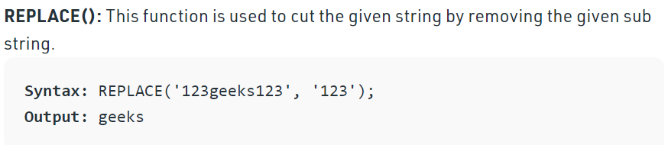

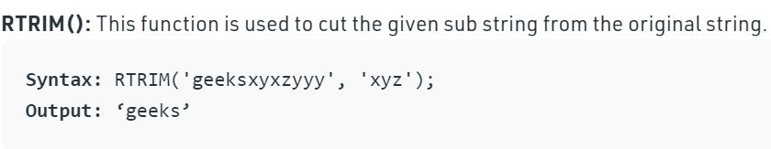

1. ***Date Functions***:

* **DATEDIFF**: Return the difference between two date values, in years, in months and in hours
  + - **Syntax in years**: SELECT DATEDIFF(year, '2017/08/25', '2011/08/25') AS DateDiff; **Result: -6**
    - **Syntax in Months:** SELECT DATEDIFF(month, '2017/08/25', '2011/08/25') AS DateDiff; **Result: -72**
    - **Syntax in Hours**: SELECT DATEDIFF(hour, '2017/08/25 07:00', '2017/08/25 12:45') AS DateDiff;

**Result: 5**

* **CURRENT_TIMESTAMP**: Return the current date and time
  + - **Syntax**: SELECT CURRENT_TIMESTAMP;
* **Months _ between ( ):** this function returns the number of months present between two given dates.
  + - **Syntax:** months _between(date1, date2)
  + **Add _ months ( ):** this function is availed to add or subtract the number of months to a given date**.**
    - **Syntax**: add _months(date, no. of months)
  + **Next _ day ( ):** this function returns the next date of a given date
    - **Syntax**: next _day (date, ‘dy’)
  + **Last_ day ( ):** this function returns the last date of a given date
    - **Syntax**: last_day (date)

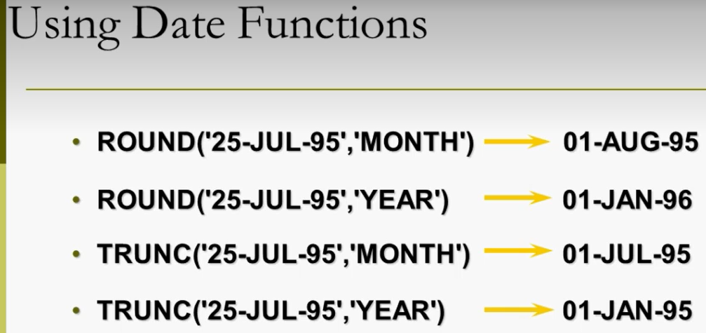

1. Conversion Functions

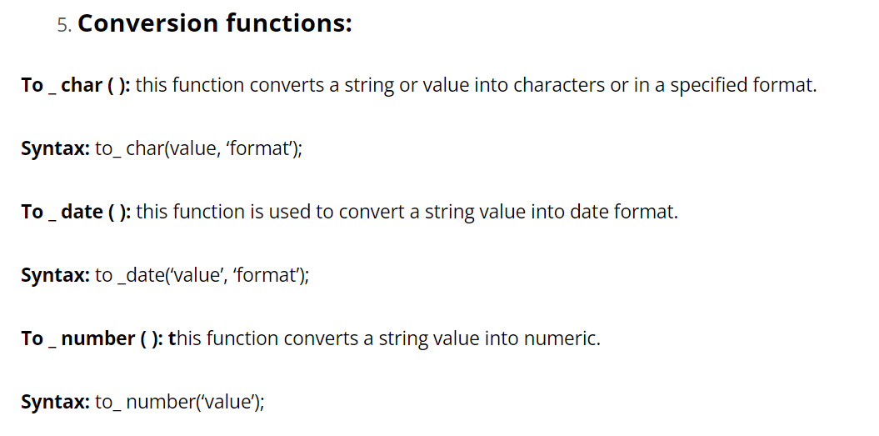

**Multiple Row functions** - Multiple row functions work upon group of rows and return one result for the complete set of rows. They are also known as Group Functions. Multiple row function is also called as group function or it is also called as aggregate function. Group function operate on set of rows to give one result per group.

**Types of Group Function/Multi-Row Functions:**

1. AVG – average value of number of rows in a table, it ignoring null value
2. COUNT – number of rows( count all selected rows using * , including duplicates and rows with null value )
3. MAX – maximum value of expression, ignore null values
4. MIN – minimum value of expression, ignore null values
5. SUM – sum of values of number of rows in a table, it ignores null values

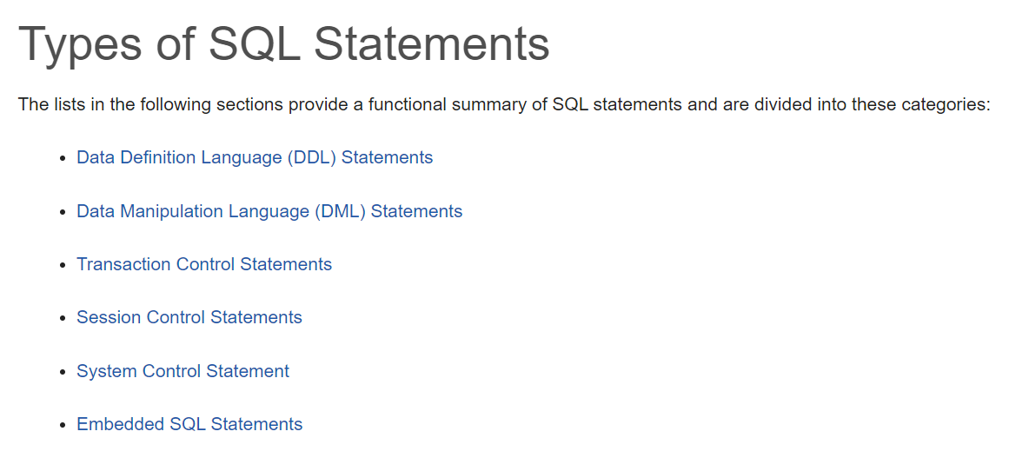

**ER Diagram:**

An Entity Relationship (ER) Diagram is a type of flowchart or type of Data Structure Diagrams that illustrates how “entities” such as people, objects or concepts relate to each other within a system. Also known as ERDs or ER Models, they use a defined set of symbols such as **rectangles, diamonds, ovals and connecting lines** to depict the interconnectedness of entities, relationships and their attributes. They mirror grammatical structure, with entities as nouns and relationships as verbs. They also depict cardinality, which defines relationships in terms of numbers.

**Components of ER Diagram:**

1. **Entity**: A definable thing—such as a person, object, concept or event—that can have data stored about it. Typically shown as a rectangle. Each record in a student table is an entity (ex. A student with a particular roll number is an entity). **Types**: Tangible and Intangible
   * **Entity type**: A group of definable things, such as students or athletes, whereas the entity would be the specific student or athlete. **Other examples:** customers, cars or products. Each record in a student table is an entity and all these represent a student object, therefore, student is the entity type.
   * **Entity Set**: The collection of all the entities in the relation of RDBMS is called an entity set. An entity set is a collection or set of all entities of a particular entity type at any point in time. The type of all the entities should be the same.

**Associative entities** are connections that describe a relationship between two different entities. These entities can have many-to-many relationships, meaning that one of the associative entities may have multiple relationships and connections to a parent or child entity. They are considered an entity because they have attributes, and they are considered a relationship because they link entities together. Represented as below:

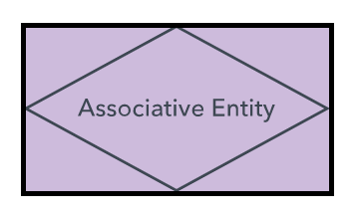

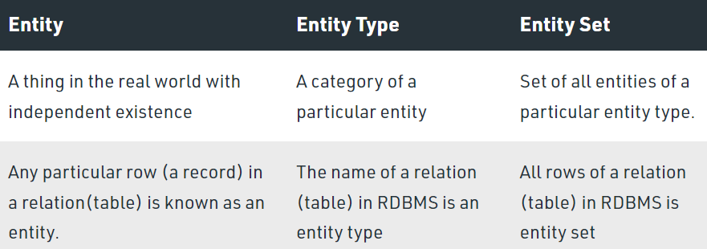 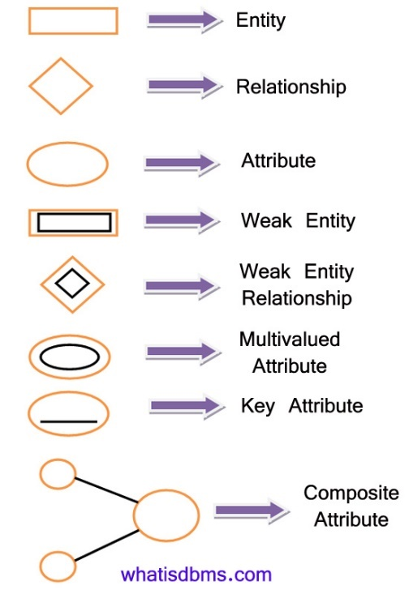

1. **Relationships**: How entities act upon each other or are associated with each other. Think of relationships as verbs. **Types of Relationships**: “1 to 1”, “1 to many or many to 1” and “many to many”.
2. **Attribute**: A property or characteristic of an entity. Often shown as an oval or circle.
   1. **Attribute Categories**:
      1. **Simple**: Means the attribute value is atomic and can’t be further divided, such as a phone number
      2. **Composite**: Sub-attributes spring from an attribute.
      3. **Derived**: Attributed is calculated or otherwise derived from another attribute, such as age from a birthdate. Represented in dotted oval.
      4. **Multi-value:** More than one attribute value is denoted, such as multiple phone numbers for a person. Represented by double ovals.
      5. **Single-value**: Just one attribute value. The types can be combined, such as: simple single-value attributes or composite multi-value attributes.

**ERD Symbols and notations:**

1. Chen Notation Style:
   1. Cardinality Notations: 1 – 1, 1 – N, N – 1, M – N;
   2. Relationships: see above
2. Crow’s Foot/Martin/Information Engineering style
3. Bachman style
4. IDEF1X style
5. Barker style

**VARCHAR2** is the same as **VARCHAR** in the oracle database. The main difference is that VARCHAR is ANSI Standard and VARCHAR2 is Oracle standard. The VarChar2 data type is used to store the character values.

**Dual Table:** The DUAL is special one row, one column table present by default in all Oracle databases. The owner of DUAL is SYS (SYS owns the data dictionary, therefore DUAL is part of the data dictionary.) but DUAL can be accessed by every user. The table has a single VARCHAR2(1) column called DUMMY that has a value of 'X'. MySQL allows DUAL to be specified as a table in queries that do not need data from any tables. In SQL Server DUAL table does not exist, but you could create one. The DUAL table was created by Charles Weiss of Oracle corporation to provide a table for joining in internal views.

The **CAST() function** converts a value (of any type) into a specified datatype.

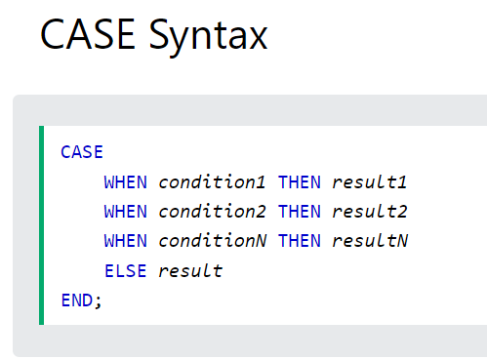 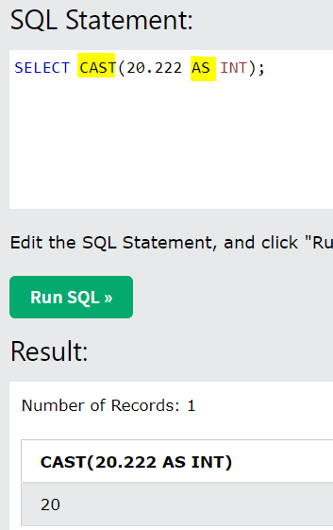

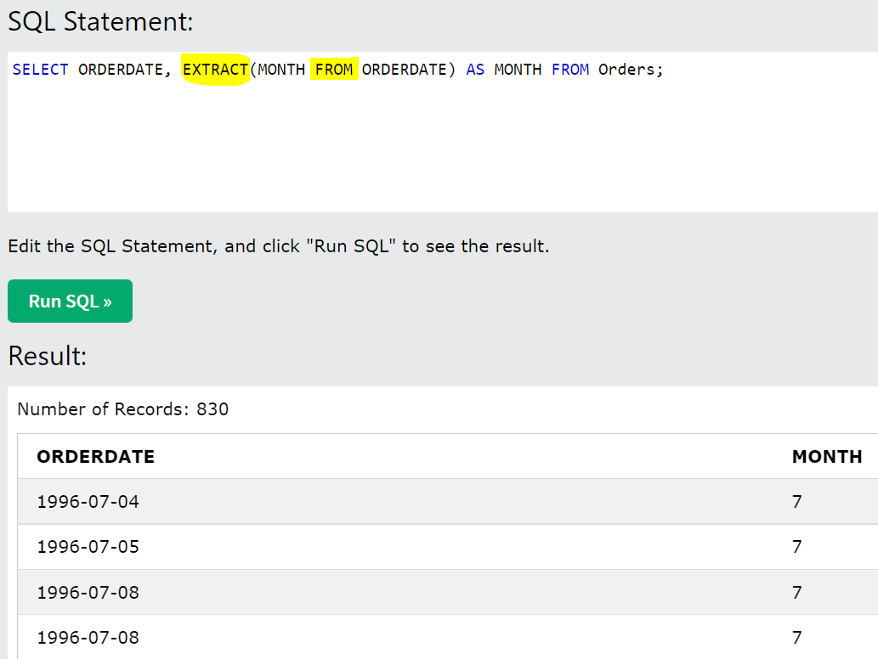

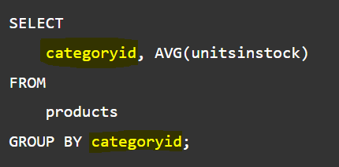

* Don’t give alias column name in HAVING clause – see screenshot below

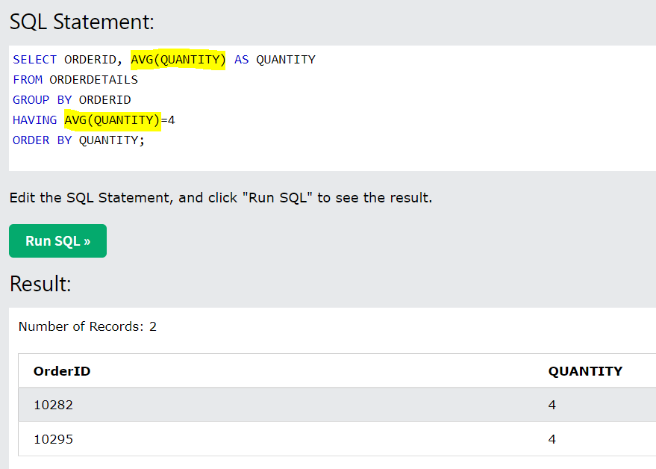

**Syntaxes**

**Constraints**:

ALTER TABLE Persons  
ADD CONSTRAINT PK_Person PRIMARY KEY (ID,LastName);

***

ALTER TABLE Persons  
DROP CONSTRAINT PK_Person;

***

ALTER TABLE Orders  
ADD FOREIGN KEY (PersonID) REFERENCES Persons(PersonID)

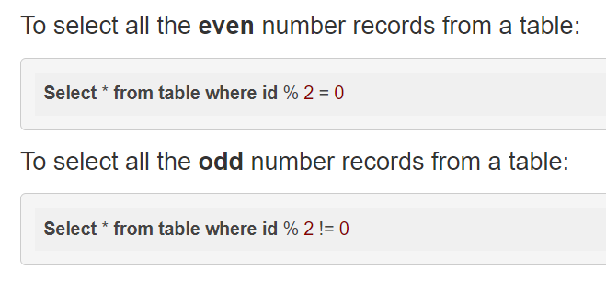

**If you want to fetch the count of distinct values**:

SELECT COUNT(DISTINCT(CITY)) FROM CUSTOMERS;

**When you need to find the difference b/w total count of some field and the distinct values in that field:**

SELECT (COUNT(CITY) - COUNT(DISTINCT(CITY))) FROM CUSTOMERS;

**Query the list of CITY names starting with vowels (i.e., a, e, i, o, or u) from STATION. Your result cannot contain duplicates.**

SELECT DISTINCT (CITY) FROM STATION WHERE CITY REGEXP '^[aeiou]'

**Query the list of *CITY* names ending with vowels (a, e, i, o, u) from**STATION**. Your result *cannot* contain duplicates.**

SELECT DISTINCT (CITY) FROM STATION WHERE CITY REGEXP '[aeiou]$'

**RegExp**: You have seen MySQL pattern matching with LIKE ...%. MySQL supports another type of pattern matching operation based on the regular expressions and the REGEXP operator. If you are aware of PHP or PERL, then it is very simple for you to understand because this matching is same like those scripting the regular expressions. Basically, LIKE does very simple wildcard matches, and REGEX is capable of very complicated wildcard matches.

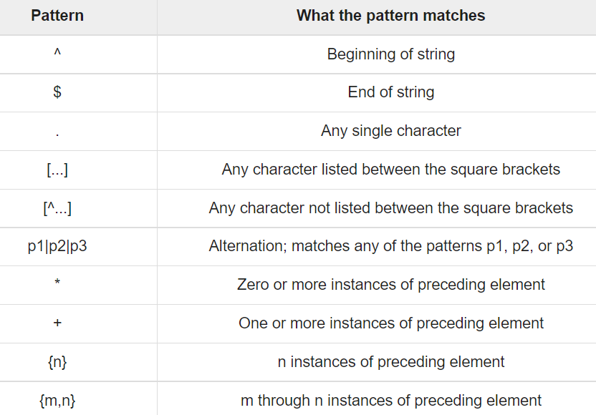

**Query the list of CITY names from STATION which have vowels (i.e., a, e, i, o, and u) as both their first and last characters. Your result cannot contain duplicates.**

SELECT DISTINCT city FROM station WHERE city RLIKE '^[aeiouAEIOU].*[aeiouAEIOU]$'

**Query the list of *CITY* names from**STATION**that *do not start* with vowels. Your result cannot contain duplicates.**

SELECT DISTINCT (CITY) FROM STATION WHERE CITY RLIKE '^[^aeiouAEIOU].*';

**Query the list of CITY names from STATION that do not end with vowels. Your result cannot contain duplicates.**

SELECT DISTINCT (CITY) FROM STATION WHERE CITY RLIKE '.*[^aeiouAEIOU]$';

**Query the list of CITY names from STATION that either do not start with vowels or do not end with vowels. Your result cannot contain duplicates.**

SELECT DISTINCT city FROM station WHERE city RLIKE '^[^aeiouAEIOU].*|.*[^AEIOUaeiou]$';

**Query the list of CITY names from STATION that do not start with vowels and do not end with vowels. Your result cannot contain duplicates.**

SELECT DISTINCT city FROM station WHERE city RLIKE '^[^aeiouAEIOU].*[^AEIOUaeiou]$';

Query the Name of any student in STUDENTS who scored higher than 75 Marks. Order your output by the last three characters of each name. If two or more students both have names ending in the same last three characters (i.e.: Bobby, Robby, etc.), secondary sort them by ascending ID.

SELECT NAME FROM STUDENTS WHERE MARKS >75 ORDER BY RIGHT(NAME,3), ID;

<https://www.tutorialspoint.com/sql/sql-operators.htm>

<https://www.tutorialspoint.com/sql/sql-quick-guide.htm>

<http://etutorials.org/SQL/Mastering+Oracle+SQL/Chapter+3.+Joins/3.2+Join+Conditions/>

Window functions: <https://www.sqlshack.com/use-window-functions-sql-server/>

<https://docs.microsoft.com/en-us/sql/t-sql/data-types/data-types-transact-sql?view=sql-server-ver15>

<https://learnsql.com/blog/sql-subqueries/>

https://learnsql.com/blog/how-to-practice-sql-joins/